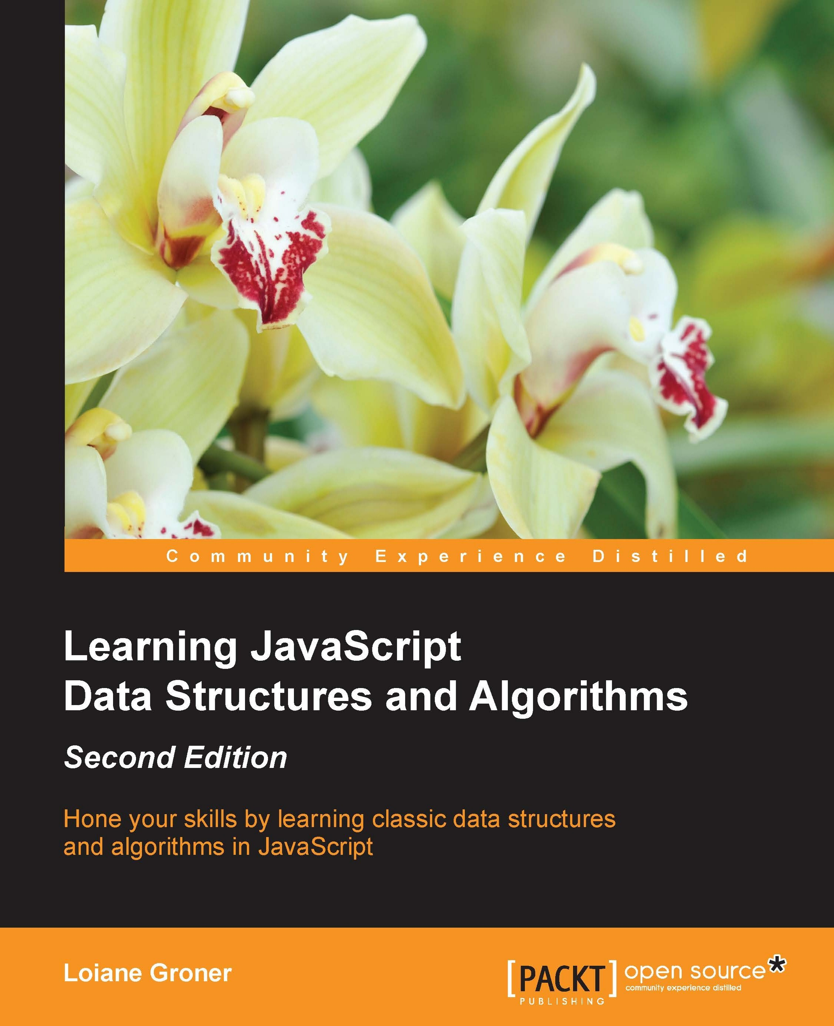

Trees8
So far in this book, we have covered some sequential data structures. The first nonsequential data structure we covered in this book was the Hash Table. In this chapter, you will learn about another non-sequential data structure called a tree, which is very useful for storing information that needs to be found easily.
In this chapter, we will cover:
Tree terminology
Creating a tree data structure
Traversing a tree
Adding and removing nodes
The AVL tree

The tree data structure
A tree is an abstract model of a hierarchical structure. The most common example of a tree in real life would be a family tree or a company organizational chart, as we can see in the following figure:
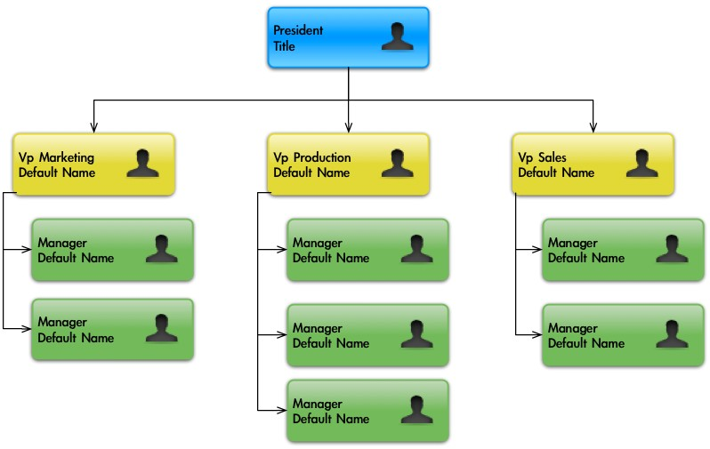

Tree terminology
A tree consists of nodes with a parent-child relationship. Each node has a parent (except for the first node at the top) and zero or more children, as in the following figure:
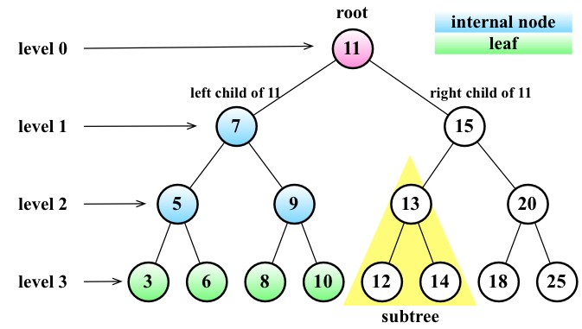
The top node of a tree is called the root (11). It is the node that does not have a parent. Each element of the tree is called a node. There are internal nodes and external nodes. An internal node is a node with at least one child (7,5,9,15,13, and 20 are internal nodes). A node that does not have children is called an external node or leaf (3,6,8,10,12,14,18, and 25 are leaves).
A node can have ancestors and descendants. The ancestors of a node (except the root) are parent, grandparent, great-grandparent, and so on. The descendants of a node are children (child), grandchildren (grandchild), great-grandchildren (great-grandchild), and so on. For example, node 5 has 7 and 11 as its ancestors and 3 and 6 as its descendants.
Another terminology used with trees is the subtree. A subtree consists of a node and its descendants. For example, the nodes 13, 12, and 14 constitute a subtree from the tree of the preceding diagram.
The depth of a node consists of the number of ancestors. For example, node 3 has a depth of 3 because it has three ancestors (5,7, and 11).
The height of a tree consists of the maximum depth of any node. A tree can also be broken down into levels. The root is on level 0, its children are on level 1, and so on. The tree from the preceding diagram has a height of 3 (the maximum depth is 3, as shown in the preceding figure level 3).
Now that we know the most important terms related to trees, we can start learning more about trees.

The binary and binary search trees
A node in a binary tree has two children at most: one left child and one right child. This definition allows us to write more efficient algorithms to insert, search, and delete nodes to/from a tree. Binary trees are largely used in computer science.
A binary search tree is a binary tree, but it only allows you to store nodes with lesser values on the left-hand side and nodes with greater values on the right-hand side. The diagram in the previous topic exemplifies a binary search tree.
This will be the data structure that we will work on in this chapter.

Creating the BinarySearchTree class
Let's start by creating our BinarySearchTree class. First, let's declare its skeleton via the following code: function BinarySearchTree() {
var Node = function(key){ //{1}
this.key = key; this.left = null; this.right = null; };
var root = null; //{2} }
The following diagram exemplifies how a Binary Search Tree (BST) is organized in terms of the data structure:
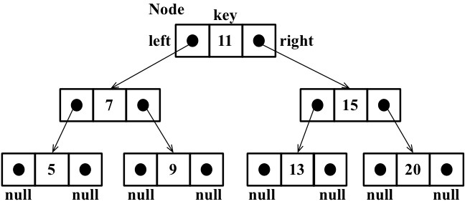
Just as in linked lists, we will work with pointers again to represent the connection between the nodes (called edges in tree terminology). When we worked with double linked lists, each node had two pointers: one to indicate the next node and another one to indicate the previous node. Working with trees, we will use the same approach (we will also work with two pointers). However, one pointer will point to the left child, and the other one will point to the right child. For this reason, we will declare a Node class that will represent each node of the tree (line {1}). A small detail that is worth noting is that instead of calling the node itself as a node or item, as we did in the previous chapters, we will call it a key. A key is how a tree node is known in tree terminology.
We will follow the same pattern we used in the LinkedList class (from Chapter 5, Linked Lists). This means that we will also declare a variable so that we can control the first node of the data structure. In the case of a tree, instead of the head, we have the root (line {2}).
Next, we need to implement some methods. The following are the methods we will implement in our tree class:
insert(key): This inserts a new key in the tree search(key): This searches for the key in the tree and returns true if it exists and false if the node does not exist inOrderTraverse: This visits all nodes of the tree using in-order traverse preOrderTraverse: This visits all nodes of the tree using pre-order traverse postOrderTraverse: This visits all the nodes of the tree using post-order traverse min: This returns the minimum value/key in the tree max: This returns the maximum value/key in the tree remove(key): This removes the key from the tree
We will implement each of these methods in the subsequent sections.

Inserting a key into a tree
The methods we will be implementing in this chapter are a little bit more complex than the ones we implemented in previous chapters. We will use a lot of recursion in our methods. If you are not familiar with recursion, refer to the Recursion section in Chapter 11, Patterns of Algorithm.
The following code is the first piece of the algorithm used to insert a new key in a tree:
this.insert = function(key){ var newNode = new Node(key); //{1}
if (root === null){ //{2} root = newNode;
} else {
insertNode(root,newNode); //{3}
}
};
To insert a new node (or item) into a tree, there are three steps we need to follow.
The first step is to create the instance of the Node class that will represent the new node (line {1}). Because of its constructor properties, we only need to pass the value we want to add to the tree, and its left and right pointers will have a null value automatically.
Second, we need to verify that the insertion is a special case. A special case would be if the node we are trying to add is the first one in the tree (line {2}). If it is, all we have to do is point the root to this new node.
The third step is to add a node to a different position than the root. In this case, we will need a helper (line {3}) private function to help us to do this, which is declared as follows:
var insertNode = function(node, newNode){ if (newNode.key < node.key){ //{4} if (node.left === null){ //{5} node.left = newNode; //{6}
} else {
insertNode(node.left, newNode); //{7}
}
} else {
if (node.right === null){ //{8} node.right = newNode; //{9}
} else {
insertNode(node.right, newNode); //{10}
}
}
};
The insertNode function will help us find out where the correct place to insert a new node is. The following list describes what this function does:
If the tree is not empty, we need to find a place to add a new node. For this reason, we will call the insertNode function by passing the root and the node as parameters (line {3}).
If the node's key is less than the current node key (in this case, it is the root (line
{4})), then we need to check the left child of the node. If there is no left node (line {5}), then we will insert the new node there (line {6}). If not, we need to descend a level in the tree by calling insertNode recursively (line {7}). In this case, the node we will compare next time will be the left child of the current node.
If the node's key is greater than the current node key and there is no right child (line {8}), then we will insert the new node there (line {9}). If not, we will also need to call the insertNode function recursively, but the new node to be compared will be the right child (line {10}).
Let's use an example so that we can understand this process better.
Consider the following scenario: we have a new tree, and we are trying to insert its first key. In this case, we will run the following code:
var tree = new BinarySearchTree(); tree.insert(11);
In this case, we will have a single node in our tree, and the root pointer will be pointing to it. The code that will be executed is in line {2} of our source code.
Now, let's consider that we already have the following tree:
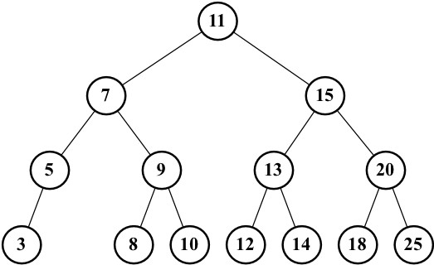
The code to create the tree seen in the preceding diagram is a continuation of the previous code (in which we inserted the 11 key), as follows:
tree.insert(7); tree.insert(15); tree.insert(5); tree.insert(3); tree.insert(9); tree.insert(8); tree.insert(10); tree.insert(13); tree.insert(12); tree.insert(14); tree.insert(20); tree.insert(18); tree.insert(25);
Also, we would like to insert a new key with the value 6, so we will execute the following code:
tree.insert(6);
The following steps will be executed:
- The tree is not empty, so the code from line {3} will be executed. The code will call the insertNode method (root, key[6]).
- The algorithm will check line {4} (key[6] < root[11] is true), then it will check line {5} (node.left[7] is not null), and finally, it will go to line {7} by calling insertNode (node.left[7], key[6]).
- We will go inside the insertNode method again, but with different parameters. It will check line {4} again (key[6] < node[7] is true), then it will check line {5} (node.left[5] is not null), and finally, it will go to line {7} by calling insertNode (node.left[5], key[6]).
- We will go once more inside the insertNode method. It will check line {4} again (key[6] < node[5] is false), then it will go to line {8} (node.right is null—node 5 does not have any right child descendents), and finally, it will execute line {9} by inserting key 6 as the right child of node 5.
- After this, the stack of method calls will pop up, and the execution will end.
This will be the result after key 6 is inserted in the tree:
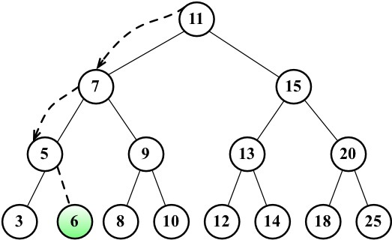

Tree traversal
Traversing (or walking) a tree is the process of visiting all the nodes of a tree and performing an operation at each node. However, how should we do this? Should we start from the top of the tree or from the bottom? From the left-hand or the right-hand side? There are three different approaches that can be used to visit all the nodes in a tree: inorder, pre-order, and post-order.
In the following sections, we will dive deeply into the uses and implementations of these three types of tree traversals.

In-order traversal
An in-order traversal visits all the nodes of a BST in an ascending order, meaning it will visit the nodes from the smallest to the largest. An application of in-order traversal would be to sort a tree. Let's check out its implementation:
this.inOrderTraverse = function(callback){ inOrderTraverseNode(root, callback); //{1} };
The inOrderTraverse method receives a callback function as a parameter. This function can be used to perform the action we want to execute when the node is visited (this is known as the visitor pattern; for more information on this, refer to
http://en.wikipedia.org/wiki/Visitor_pattern). As most algorithms we are implementing for the BST are recursive, we will use a private helper function that will receive node and the callback function to help us with it (line {1}). Execute the following code:
var inOrderTraverseNode = function (node, callback) {
if (node !== null) { //{2}
inOrderTraverseNode(node.left, callback); //{3} callback(node.key); //{4} inOrderTraverseNode(node.right, callback); //{5}
}
};
To traverse a tree using the in-order method, we need to first check whether the tree node that was passed as a parameter is null (this is the point where the recursion stops being executed, line {2}, which is the base case of the recursion algorithm).
Next, we will visit the left node (line {3}) by calling the same function recursively. Then, we will visit the root node (line {4}) by performing an action with it (callback), and then we will visit the right node (line {5}).
Let's try to execute this method using the tree from the previous topic as an example, as follows:
function printNode(value){ //{6}
console.log(value);
}
tree.inOrderTraverse(printNode); //{7}
However, first, we need to create a callback function (line {6}). All we will do is print the node's value on the browser's console. Then, we can call the inOrderTraverse method by passing our callback function as a parameter (line {7}). When we execute this code, the following will be the output in the console (each number will be output on a different line):
3 5 6 7 8 9 10 11 12 13 14 15 18 20 25
The following diagram illustrates the path that the inOrderTraverse method followed:
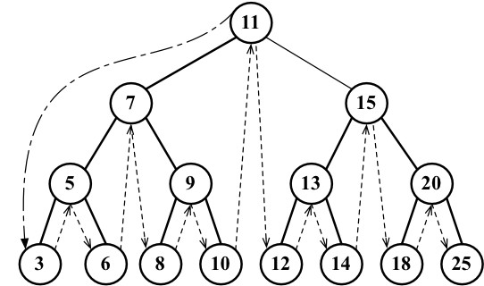

Pre-order traversal
A pre-order traversal visits the node prior to its descendants. An application of pre-order traversal could be to print a structured document.
Let's take a look at its implementation:
this.preOrderTraverse = function(callback){ preOrderTraverseNode(root, callback); };
The preOrderTraverseNode method implementation is as follows:
var preOrderTraverseNode = function (node, callback) {
if (node !== null) { callback(node.key); //{1}
preOrderTraverseNode(node.left, callback); //{2} preOrderTraverseNode(node.right, callback); //{3}
}
};
The difference between the in-order and pre-order traversals is that the pre-order one visits the root node first (line {1}), then the left node (line {2}), and finally the right node (line {3}), while the in-order traversal executes the lines in the following order: lines {2}, {1}, and {3}.
The following will be the output in the console (each number will be output on a different line):
11 7 5 3 6 9 8 10 15 13 12 14 20 18 25
The following diagram illustrates the path followed by the preOrderTraverse method:
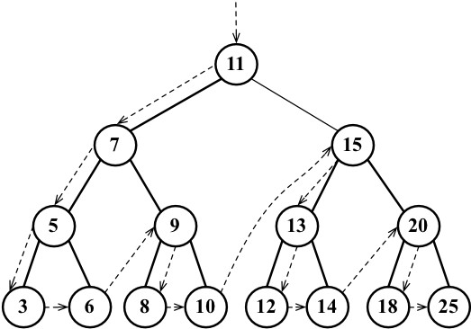

Post-order traversal
A post-order traversal visits the node after it visits its descendants. An application of postorder traversal could be computing the space used by a file in a directory and its subdirectories.
Let's take a look at its implementation:
this.postOrderTraverse = function(callback){ postOrderTraverseNode(root, callback); };
The postOrderTraverseNode implementation is as follows:
var postOrderTraverseNode = function (node, callback) {
if (node !== null) {
postOrderTraverseNode(node.left, callback); //{1} postOrderTraverseNode(node.right, callback); //{2} callback(node.key); //{3}
}
};
In this case, the post-order traversal will visit the left node (line {1}), then the right node (line {2}), and at last, the root node (line {3}).
As you can see, the algorithms for the in-order, pre-order, and post-order approaches are very similar; the only thing that changes is the order in which lines {1}, {2}, and {3} are executed in each method.
This will be the output in the console (each number will be output on a different line):
3 6 5 8 10 9 7 12 14 13 18 25 20 15 11
The following diagram illustrates the path the postOrderTraverse method followed:
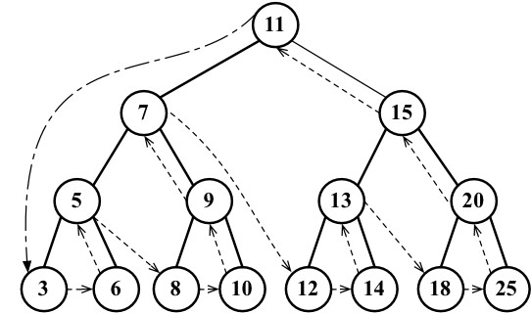

Searching for values in a tree
There are three types of searches that are usually performed in trees:
Searching for minimum values
Searching for maximum values Searching for a specific value
Let's take a look at each one.

Searching for minimum and maximum values
Let's use the following tree for our examples:
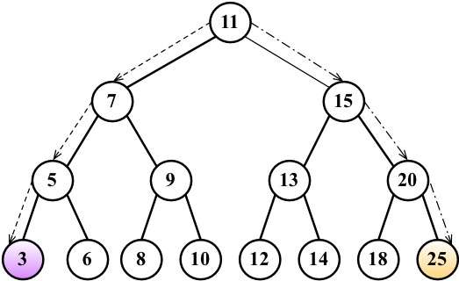
Just looking at the preceding figure, could you easily find the minimum and maximum values of the tree?
If you take a look at the leftmost node in the last level of the tree, you will find the value 3, which is the lowest key from this tree. And if you take a look at the node that is furthest to the right (also in the last level of the tree), you will find the key 25, which is the highest key in this tree. This information helps us a lot when implementing methods that will find the minimum and maximum nodes of the tree.
First, let's take a look at the method that will find the minimum key of the tree, as follows:
this.min = function() { return minNode(root); //{1} };
The min method will be the method exposed to the user. This method calls the minNode method (line {1}), as follows:
var minNode = function (node) {
if (node){
while (node && node.left !== null) { //{2} node = node.left; //{3} }
return node.key;
}
return null; //{4}
};
The minNode method allows us to find the minimum key from any node of the tree. We can use it to find the minimum key from a subtree or from the tree itself. For this reason, we will call the minNode method by passing the tree root (line {1}) because we want to find the minimum key of the whole tree.
Inside the minNode method, we will traverse the left edge of the tree (lines {2} and {3}) until we find the node at the highest level of the tree (the leftmost end).
In a similar way, we also have the max method, which looks similar to the following:
this.max = function() { return maxNode(root); };
var maxNode = function (node) {
if (node){
while (node && node.right !== null) { //{5}
node = node.right; }
return node.key;
}
return null; };
To find the maximum key, we will traverse the right edge of the tree (line {5}) until we find the last node at the right-hand end of the tree.
So, for the minimum value, we will always go to the left-hand side of the tree, and for the maximum value, we will always navigate to the right-hand side of the tree.

Searching for a specific value
In previous chapters, we also implemented the find, search, and get methods to find a specific value in the data structure (which is similar to the has method we implemented in previous chapters). We will implement the search method for the BST as well. Let's take a look at its implementation:
this.search = function(key){ return searchNode(root, key); //{1} }; var searchNode = function(node, key){ if (node === null){ //{2}
return false;
}
if (key < node.key){ //{3}
return searchNode(node.left, key); //{4}
} else if (key > node.key){ //{5} return searchNode(node.right, key); //{6}
} else {
return true; //{7}
}
};
The first thing we need to do is declare the search method. Following the pattern of other methods declared for BST, we will use a helper function to help us (line {1}).
The searchNode method can be used to find a specific key in the tree or any of its subtrees. This is the reason we will call this method in line {1} by passing the root tree as a parameter.
Before we start the algorithm, we will validate that the node passed as a parameter is valid (is not null). If it is, it means that the key was not found, and we will return false.
If the node is not null, we need to continue the verification. If the key we are looking for is lower than the current node (line {3}), then we will continue the search using the left child subtree (line {4}). If the value we are looking for is greater than the current node (line {5}), then we will continue the search from the right child of the current node (line {6}). Otherwise, it means that the key we are looking for is equal to the current node's key, and we will return true to indicate that we found the key (line {7}).
We can test this method using the following code:
console.log(tree.search(1) ? 'Key 1 found.' : 'Key 1 not found.'); console.log(tree.search(8) ? 'Key 8 found.' : 'Key 8 not found.');
It will output the following:
Value 1 not found.
Value 8 found.
Let's go into more detail on how the method was executed to find key 1:
- We called the searchNode method, passing the root as a parameter (line {1}). The node[root[11]] is not null (line {2}), so we will go to line {3}.
- The key[1] < node[11] is true (line {3}), so we will go to line {4} and call the searchNode method again, passing node[7], key[1] as a parameters.
- The node[7] is not null (line {2}), so we will go to line {3}.
- The key[1] < node[7] is true (line {3}), so we will go to line {4} and call the searchNode method again, passing node[5], key[1] as a parameters.
- The node[5] is not null (line {2}), so we will go to line {3}.
- The key[1] < node[5] is true (line {3}), so we will go to line {4} and call the searchNode method again, passing node[3], key[1] as a parameters.
- The node[3] is not null (line {2}), so we will go to line {3}.
- The key[1] < node[3] is true (line {3}), so we will go to line {4} and call the searchNode method again, passing null, key[1] as a parameters. The null was passed as a parameter because node[3] is a leaf (it does not have children, so the left child will have the value null).
- The node is null (in line {2}, the node to search in this case is null), so we will return false.
- After this, the stack of method calls will pop up, and the execution will end.
Let's do the same exercise to search value 8, as follows:
- We called the searchNode method, passing root as a parameter (line {1}). The node[root[11]] is not null (line {2}), so we will go to line {3}.
- The key[8] < node[11] is true (line {3}), so we will go to line {4} and call the searchNode method again, passing node[7], key[8] as a parameters.
- The node[7] is not null (line {2}), so we will go to line {3}.
- The key[8] < node[7] is false (line {3}), so we will go to line {5}.
- The key[8] > node[7] is true (line {5}), so we will go to line {6} and call the searchNode method again, passing node[9], key[8] as a parameters.
- The node[9] is not null (line {2}), so we will go to line {3}.
- The key[8] < node[9] is true (line {3}), so we will go to line {4} and call the searchNode method again, passing node[8], key[8] as a parameters.
- The node[8] is not null (line {2}), so we will go to line {3}.
- The key[8] < node[8] is false (line {3}), so we will go to line {5}.
- The key[8] > node[8] is false (line {5}), so we will go to line {7} and return true because node[8] is the key we were looking for.
- After this, the stack of method calls will pop up, and the execution will end.

Removing a node
The next and final method we will implement for our BST is the remove method. This is the most complex method we will implement in this book. Let's start with the method that will be available to be called from a tree instance, as follows: this.remove = function(key){ root = removeNode(root, key); //{1} };
This method receives the desired key to be removed, and it also calls removeNode, passing root and key to be removed as parameters (line {1}). One very important thing to note is that the root receives the return of the method removeNode. We will understand why in a second.
The complexity of the removeNode method is due to the different scenarios that we need to handle and also because it is recursive.
Let's take a look at the removeNode implementation, as follows:
var removeNode = function(node, key){
if (node === null){ //{2}
return null;
}
if (key < node.key){ //{3}
node.left = removeNode(node.left, key); //{4} return node; //{5}
} else if (key > node.key){ //{6}
node.right = removeNode(node.right, key); //{7} return node; //{8} } else { // key is equal to node.key
//case 1 - a leaf node
if (node.left === null && node.right === null){ //{9}
node = null; //{10} return node; //{11} }
//case 2 - a node with only 1 child if (node.left === null){ //{12} node = node.right; //{13} return node; //{14}
} else if (node.right === null){ //{15}
node = node.left; //{16} return node; //{17}
}
//case 3 - a node with 2 children var aux = findMinNode(node.right); //{18}
node.key = aux.key; //{19}
node.right = removeNode(node.right, aux.key); //{20}
return node; //{21}
}
};
As a stop point we have line {2}. If the node we are analyzing is null, it means the key does not exist in the tree, and for this reason, we will return null.
Then, the first thing we need to do is to find the node in the tree. So, if the key we are looking for has a lower value than the current node (line {3}), then we will go to the next node at the left-hand side edge of the tree (line {4}). If the key is greater than the current node (line {6}), then we will go the next node at the right-hand side edge of the tree (line {7}).
If we find the key we are looking for (key is equal to node.key), then we will have three different scenarios to handle.
The findMinNode function is presented as follows:
var findMinNode = function(node){ while (node && node.left !== null) {
node = node.left;
}
return node; };

Removing a leaf node
The first scenario is a leaf node that does not have a left or right child line {9}. In this case, all we have to do is get rid of this node by assigning null to it (line {9}). However, as you learned during the implementation of linked lists, we know that assigning null to the node is not enough, and we also need to take care of the pointers. In this case, the node does not have any children, but it has a parent node. We need to assign null to its parent node, and this can be done by returning null (line {11}).
As the node already has the value null, the parent pointer to the node will receive this value as well. And this is the reason we are returning the node value as the return function. The parent node will always receive the value returned from the function. An alternative to this approach could be passing the parent and the node as a parameter of the method.
If we take a look back at the first lines of the code of this method, we will notice that we are updating the pointer values of the left and right pointers of the nodes in lines {4} and {7}, and we are also returning the updated node in lines {5} and {8}.
The following diagram exemplifies the removal of a leaf node:
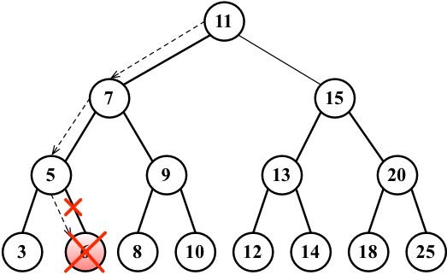

Removing a node with a left or right child
Now, let's take a look at the second scenario, which is a node that has a left or right child. In this case, we need to skip this node and assign the parent pointer to the child node.
If the node does not have a left child (line {12}), it means it has a right child. So, we will change the reference of the node to its right child (line {13}) and return the updated node (line {14}). We will do the same if the node does not have the right child (line {15}); we will update the node reference to its left child (line {16}) and return the updated value (line {17}).
The following diagram exemplifies the removal of a node with only a left or right child:
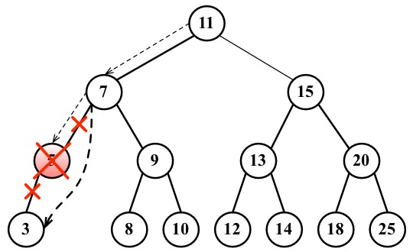

Removing a node with two children
Now comes the third scenario and the most complex one, which is the scenario where the node we are trying to remove has two children: the right and left one. To remove a node with children, there are four steps that need to be performed, as follows:
- Once we find the node we want to remove, we need to find the minimum node from its right-hand side edge subtree (its successor line {18}).
- Then, we will update the value of the node with the key of the minimum node from its right-hand side subtree (line {19}). With this action, we are replacing the key of the node, which means it was removed.
- However, now we have two nodes in the tree with the same key, and this cannot happen. What we need to do now is remove the minimum node from the right subtree as we moved it to the place of the removed node (line {20}).
- Finally, we will return the updated node reference to its parent (line {21}).
The implementation of the findMinNode method is exactly the same as the min method. The only difference is that in the min method, we are returning only the key, and in the findMinNode method, we are returning the node.
The following diagram exemplifies the removal of a node with only a left child and a right child:
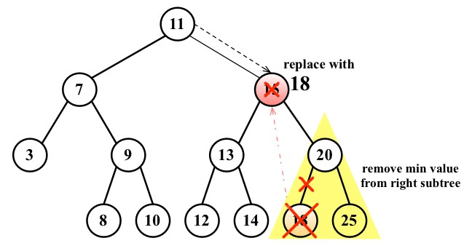

Self-balancing trees
Now that you know how to work with BST, you can dive into the study of trees if you want to.
BST has a problem: depending on how many nodes you add, one of the edges of the tree can be very deep, meaning a branch of the tree can have a high level and another branch can have a low level, as shown in the following diagram:
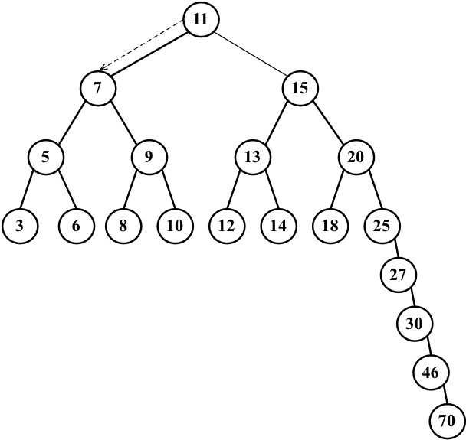
This can cause performance issues when adding, removing, and searching for a node on a particular edge of the tree. For this reason, there is a tree called the Adelson-Velskii and Landi's tree (AVL tree). The AVL tree is a self-balancing BST tree, which means the height of both the left and right subtrees of any node differs by 1 at most. You will learn more about the AVL tree in the next topic.

Adelson-Velskii and Landi's tree (AVL tree)
The AVL tree is a self-balancing tree, meaning the tree tries to self-balance whenever a node is added to it or removed from it. The height of the left or right subtree of any node (and any level) differs by 1 at most. This means the tree will try to become a complete tree whenever possible while adding or removing a node.

Inserting a node in the AVL tree
Inserting and removing nodes in an AVL tree works the same way as in BST. However, the difference in the AVL tree is that we will need to verify its balance factor, and if needed, we will apply the logic to self-balance the tree.
The following code inserts a new node in an ALV tree:
var insertNode = function(node, element) {
if (node === null) { node = new Node(element);
} else if (element < node.key) { node.left = insertNode(node.left, element);
if (node.left !== null) {
//verify if balancing is needed {1}
}
} else if (element > node.key) {
node.right = insertNode(node.right, element);
if (node.right !== null) {
//verify if balancing is needed {2}
}
}
return node; };
However, whenever we insert a new node, we need to check whether the tree needs to be balanced (lines {1} and {2}).

Calculating the balance factor
In an AVL tree, for every node, we need to calculate the difference between the height of the right-hand side subtree (hr) and the left-hand side subtree (hl). The result of hr – hl needs to be 0, 1, or -1. If the result is different from these values, it means the tree needs to be balanced. This concept is called the balance factor.
The following diagram exemplifies the balance factor of some trees (all trees are balanced):
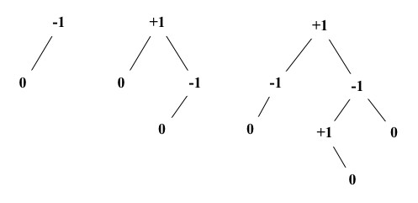
The code to calculate the height of a node is given as follows:
var heightNode = function(node) {
if (node === null) { return -1;
} else {
return Math.max(heightNode(node.left),
heightNode(node.right)) + 1;
}
};
So, if we are inserting a new node in a left-hand side subtree, we will calculate the height, and if it is larger than 1 (meaning it is not -1, 0 or 1), then we will balance the left-hand side subtree, as follows:
//this code replaces line {1} from insertNode method if ((heightNode(node.left) - heightNode(node.right)) > 1){
// do rotations {3}
}
We will apply the same logic if we are inserting a node in a right-hand side subtree via the following code:
//this code replaces line {2} from insertNode method if ((heightNode(node.right) - heightNode(node.left)) > 1){
// do rotations {4}
}

AVL rotations
When inserting nodes to an AVL tree, there are two balancing processes that can be used: simple rotation or double rotation. Between simple rotation and double rotation, there are four scenarios:
Right-Right (RR): This is a single rotation to the left
Left-Left (LL): This is a single rotation to the right
Left-Right (LR): This is a double rotation to the right Right-Left (RL): This is a double rotation to the left
Let's consider how each one works.
Right-Right (RR): A single rotation to the left Consider the following diagram:
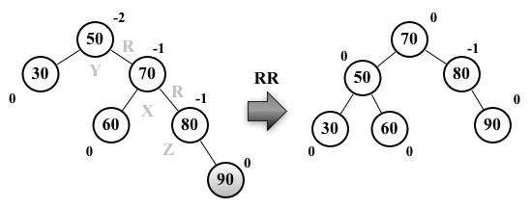
Suppose node 90 was the last one inserted in the AVL tree. This would make the tree unbalanced (node 50 –Y has height -2), so we would need to balance it. These are the steps we will perform to balance the tree:
Node X, which is in the middle of the three nodes involved in the balancing (X, Y, and Z), will take place of the node Y, which has a balance factor of -2 (line {1})
Node X, the right-hand side subtree, will not be changed
Node X, the left-hand side subtree (node Z), will be placed as the right-hand side subtree of node Y (line {2})
Node X, the left-hand side child, will reference node Y (line {3})
The following code exemplifies this process:
var rotationRR = function(node) { var tmp = node.right; //{1} node.right = tmp.left; //{2} tmp.left = node; //{3}
return tmp; };
Left-Left (LL): a single rotation to the right Consider the following diagram:
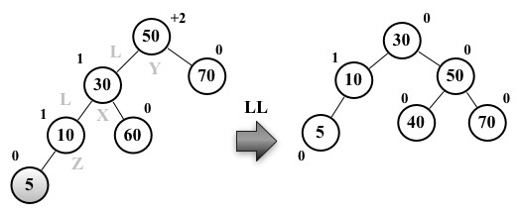
Suppose node 5 was the last one inserted in the AVL tree. This would make the tree unbalanced (node 50 –Y has height +2), so we would need to balance it. These are the steps we will perform to balance the tree:
Node X, which is in the middle of the three nodes involved in the balancing (X, Y, and Z), will take the place of node Y, which has a balance factor of +2 (line {1})
Node X, the left-hand side subtree, will not be changed
Node X, the right-hand side subtree (node Z), will be placed as the left-hand side subtree of node Y (line {2})
Node X, the right-hand side child, will reference node Y (line {3})
The following code exemplifies this process:
var rotationLL = function(node) { var tmp = node.left; //{1} node.left = tmp.right; //{2} tmp.right = node; //{3}
return tmp;
};
Left-Right (LR): a double rotation to the right Consider the following diagram:
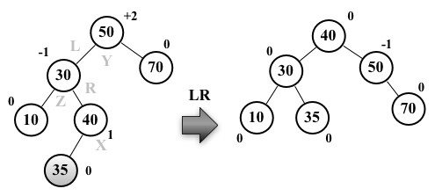
Suppose node 35 was the last one inserted in the AVL tree. This would make the tree unbalanced (node 50 –Y has height +2), so we would need to balance it. These are the steps we will perform to balance the tree:
Node X will take place of node Y, which has a balance factor of +2
Node X, the right-hand side subtree (node Z), will be placed as the left-hand side subtree of node Y
Node X, the left-hand side subtree, will be placed as the right-hand side subtree of node Z
Node X, the right-hand side child, will reference node Y Node X, the left-hand side child, will reference node Z
So basically, we are doing an RR rotation first and then an LL rotation.
The following code exemplifies this process:
var rotationLR = function(node) { node.left = rotationRR(node.left);
return rotationLL(node); };
Right-Left (RL): a double rotation to the left
Consider the following diagram:
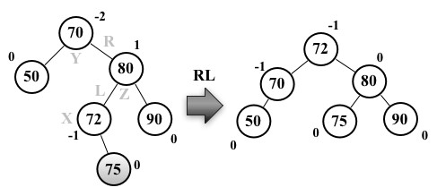
Suppose node 75 was the last one inserted in the AVL tree. This would make the tree unbalanced (node 70 –Y has height -2), so we would need to balance it. These are the steps we will perform to balance the tree:
Node X will take the place of node Y, which has a balance factor of -2
Node X, the right-hand side subtree (node Z), will be placed as the left-hand side subtree of node Z
Node X, the left-hand side subtree, will be placed as the right-hand side subtree of node Y
Node X, the right-hand side child, will reference node Y Node X, the left-hand side child, will reference node Z
So basically, we are doing an LL rotation first and then an RR rotation.
The following code exemplifies this process:
var rotationRL = function(node) { node.right = rotationLL(node.right);
return rotationRR(node); };

Completing the insertNode method
After verifying that the tree needs to be balanced, we just need to apply the correct rotation for each case.
If we are inserting a node in the left-hand side subtree and the value of the node is smaller than the value of its left-hand side child, we will do an LL rotation. Otherwise, we will do an LR rotation. The code that exemplifies this process is given here:
//this code replaces line {1} from insertNode method if ((heightNode(node.left) - heightNode(node.right)) > 1){ // do rotations {3} if (element < node.left.key){ node = rotationLL(node);
} else {
node = rotationLR(node);
}
}
If we are inserting a node in the right-hand side subtree and the value of the node is bigger than the value of its right-hand side child, we will do an RR rotation. Otherwise, we will do an RL rotation. The code that exemplifies this process is given as follows:
//this code replaces line {2} from insertNode method if ((heightNode(node.right) - heightNode(node.left)) > 1){
// do rotations {4} if (element > node.right.key){ node = rotationRR(node);
} else {
node = rotationRL(node);
}
}

More about binary trees
Although the AVL tree is a self-balanced tree, sometimes its performance in inserting or removing nodes is not the best one. A better option would be using the Red-Black tree.
The Red-Black tree allows an efficient in-order traversal of its nodes
(http://goo.gl/OxED8K). Although we will not cover this tree in this book, you can find its source code within the book's code bundle.
You should also check out the Heap tree (http://goo.gl/SFlhW6) if you want to learn more about trees.

Summary
In this chapter, we covered the algorithms to add, search, and remove items from a binary search tree, which is the basic tree data structure largely used in computer science. We covered three traversal approaches to visit all the nodes of a tree. You also learned how to develop a self-balanced tree named the AVL tree.
In the next chapter, we will study the basic concepts of graphs, which are also a nonlinear data structure.

Graphs9
In this chapter, you will learn about another nonlinear data structure called graph. This will be the last data structure we will cover before diving into sorting and searching algorithms.
This chapter will cover a considerable part of the wonderful applications of graphs. Since this is a vast topic, we could write a book like this just to dive into the amazing world of graphs.

Graph terminology
A graph is an abstract model of a network structure. A graph is a set of nodes (or vertices) connected by edges. Learning about graphs is important because any binary relationship can be represented by a graph.
Any social network, such as Facebook, Twitter, and Google+, can be represented by a graph.
We can also use graphs to represent roads, flights, and communications, as shown in the following image:
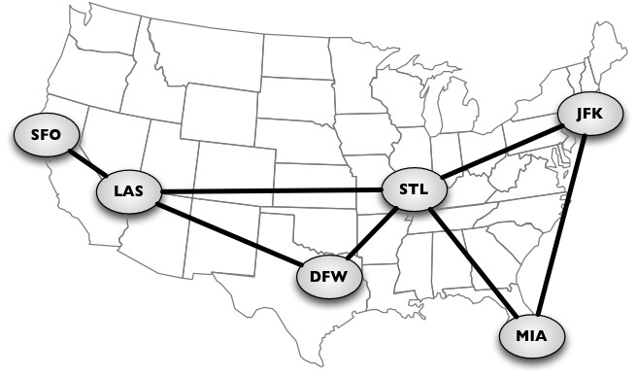
Let's learn more about the mathematical and technical concepts of graphs.
A graph G = (V, E) is composed of:
V: A set of vertices
E: A set of edges connecting the vertices in V
The following diagram represents a graph:
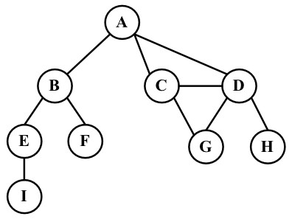
Let's cover some graph terminology before we start implementing any algorithms.
Vertices connected by an edge are called adjacent vertices. For example, A and B are adjacent, A and D are adjacent, A and C are adjacent, and A and E are not adjacent.
A degree of a vertex consists of the number of adjacent vertices. For example, A is connected to other three vertices, therefore, A has degree 3; E is connected to other two vertices, therefore, E has degree 2.
A path is a sequence of consecutive vertices, such as v1, v2, …, vk, where vi and vi+1 are adjacent. Using the graph from the previous diagram as an example, we have the paths A B E I and A C D G, among others.
A simple path does not contain repeated vertices. As an example, we have the path A D G. A cycle is a simple path, except for the last vertex, which is the same as the first vertex: A D C A (back to A).
A graph is acyclic if it does not have cycles. A graph is connected if there is a path between every pair of vertices.

Directed and undirected graphs
Graphs can be undirected (where edges do not have a direction) or directed (digraph), where edges have a direction, as demonstrated here:
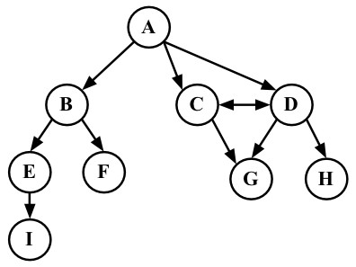
A graph is strongly connected if there is a path in both directions between every pair of vertices. For example, C and D are strongly connected, while A and B are not strongly connected.
Graphs can also be unweighted (as we have noted so far) or weighted (in which the edges have weights), as shown in the following diagram:
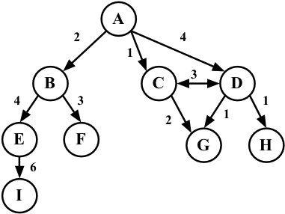
We can solve many problems in the computer science world using graphs, such as searching a graph for a specific vertex or searching for a specific edge, finding a path in the graph (from one vertex to another), finding the shortest path between two vertices, and cycle detection.

Representing a graph
There are a few ways in which we can represent graphs when it comes to data structures. There is no correct way of representing a graph among the existing possibilities. It depends on the type of problem you need to resolve and the type of graph as well.

The adjacency matrix
The most common implementation is the adjacency matrix. Each node is associated with an integer, which is the array index. We will represent the connectivity between vertices using a two-dimensional array, as array[i][j] = = = 1 if there is an edge from the node with index i to the node with index j or as array[i][j] = = = 0 otherwise, as demonstrated by the following diagram:
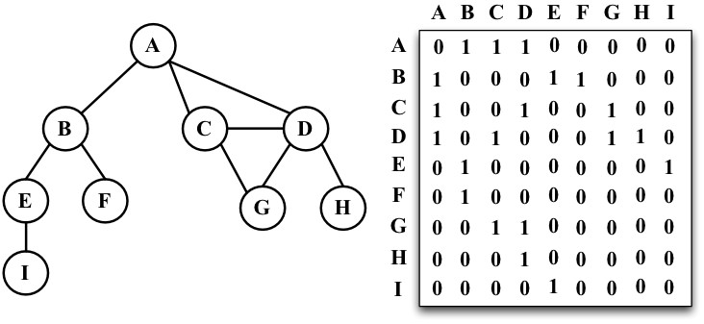
Graphs that are not strongly connected (sparse graphs) will be represented by a matrix with many zero entries in the adjacency matrix. This means we would waste space in the computer memory to represent edges that do not exist; for example, if we need to find the adjacent vertices of a given vertex, we will have to iterate through the whole row even if this vertex has only one adjacent vertex. Another reason this might not be a good representation is that the number of vertices in the graph may change, and a twodimensional array is inflexible.

The adjacency list
We can use a dynamic data structure to represent graphs as well, called an adjacency list. This consists of a list of adjacent vertices for every vertex of the graph. There are a few different ways we can represent this data structure. To represent the list of adjacent vertices, we can use a list (array), a linked list, or even a hash map or dictionary. The following diagram exemplifies the adjacency list data structure:
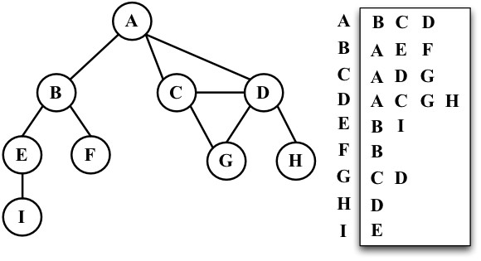
Both representations are very useful and have different properties (for example, finding out whether the vertices v and w are adjacent is faster using an adjacent matrix), although adjacency lists are probably better for most problems. We will use the adjacency list representation for the examples in this book.

The incidence matrix
We can also represent a graph using an incidence matrix. In an incidence matrix, each row of the matrix represents a vertex, and each column represents an edge. We will represent the connectivity between two objects using a two-dimensional array, as array[v][e] = = = 1 if the vertex v is incident upon edge e or as array[v][e] = = = 0 otherwise, as demonstrated in the following diagram:
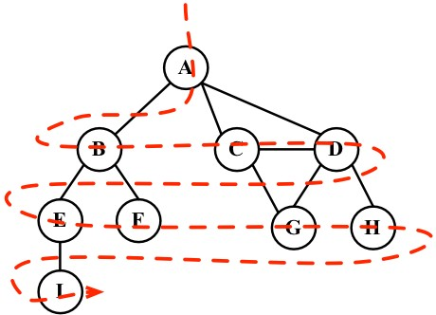
An incidence matrix is usually used to save space and memory when we have more edges than vertices.

Creating the Graph class
As usual, we will declare the skeleton of our class:
function Graph() { var vertices = []; //{1}
var adjList = new Dictionary(); //{2} }
We will use an array to store the names of all the vertices of the graph (line {1}), and we will use a dictionary (implemented in Chapter 7, Dictionaries and Hashes) to store the adjacent list (line {2}). The dictionary will use the name of the vertex as a key and the list of adjacent vertices as a value. Both the vertices array and the adjList dictionary are private attributes of our Graph class.
Next, we will implement two methods: one to add a new vertex to the graph (because when we instantiate the graph, it will create an empty one) and another method to add edges between the vertices. Let's implement the addVertex method first, as follows:
this.addVertex = function(v){ vertices.push(v); //{3} adjList.set(v, []); //{4} };
This method receives a vertex v as a parameter. We will add this vertex to the list of vertices (line {3}), and we will also initialize the adjacent list with an empty array by setting the dictionary value of the vertex v key with an empty array (line {4}).
Now, let's implement the addEdge method via the following code:
this.addEdge = function(v, w){ adjList.get(v).push(w); //{5} adjList.get(w).push(v); //{6} };
This method receives two vertices as parameters. First, we will add an edge from vertex v to vertex w (line {5}) by adding w to the adjacent list of v. If you want to implement a directed graph, line {5} is enough. As we are working with undirected graphs in most examples in this chapter, we also need to add an edge from w to v (line {6}).

Note that we are only adding new elements to the array as we have
already initialized it in line
{4}
.
Let's test this code, as follows:
var graph = new Graph();
var myVertices = ['A','B','C','D','E','F','G','H','I']; //{7}
for (var i=0; i<myVertices.length; i++){ //{8}
graph.addVertex(myVertices[i]);
}
graph.addEdge('A', 'B'); //{9} graph.addEdge('A', 'C'); graph.addEdge('A', 'D'); graph.addEdge('C', 'D'); graph.addEdge('C', 'G'); graph.addEdge('D', 'G'); graph.addEdge('D', 'H'); graph.addEdge('B', 'E'); graph.addEdge('B', 'F'); graph.addEdge('E', 'I');
To make our lives easier, let's create an array with all the vertices we want to add to our graph (line {7}). Then, we only need to iterate through the vertices array and add the values one by one to our graph (line {8}). Finally, we will add the desired edges (line {9}). This code will create the graph we used in the diagrams presented so far in this chapter.
To make our lives even easier, let's also implement the toString method for this Graph class so that we can output the graph on the console:
this.toString = function(){
var s = '';
for (var i=0; i<vertices.length; i++){ //{10}
s += vertices[i] + ' -> ';
var neighbors = adjList.get(vertices[i]); //{11} for (var j=0; j<neighbors.length; j++){ //{12}
s += neighbors[j] + ' ';
}
s += '\n'; //{13}
} return s; };
We will build a string with the adjacent list representation. First, we will iterate the list of vertices arrays (line {10}) and add the name of the vertex to our string. Then, we will get the adjacent list for this vertex (line {11}), and we will also iterate it (line {12}) to get the name of the adjacent vertex and add it to our string. After we iterate the adjacent list, we will add a new line to our string (line {13}) so that we can see a pretty output on the console. Let's try this code:
console.log(graph.toString());
This will be the output:
- -> B C D
- -> A E F
- -> A D G
- -> A C G H
- -> B I
- -> B
- -> C D
- -> D
- -> E
A pretty adjacent list! From this output, we know that vertex A has the following adjacent vertices: B, C, and D.

Graph traversals
Similar to the tree data structure, we can also visit all the nodes of a graph. There are two algorithms that can be used to traverse a graph, called breadth-first search (BFS) and depth-first search (DFS). Traversing a graph can be used to find a specific vertex or a path between two vertices, to check whether the graph is connected, to check whether it contains cycles, and so on.
Before we implement the algorithms, let's try to better understand the idea of traversing a graph.
The idea of graph traversal algorithms is that we must track each vertex when we first visit it and keep track of which vertices have not yet been completely explored. For both traversal graph algorithms, we need to specify which will be the first vertex to be visited.
To completely explore a vertex, we need to look at each edge of this vertex. For each edge connected to a vertex that has not been visited yet, we will mark it as discovered and add it to the list of vertices to be visited.
In order to have efficient algorithms, we must visit each vertex twice at the most when each of its endpoints is explored. Every edge and vertex in the connected graph will be visited.
The BFS and DFS algorithms are basically the same with only one difference, which is the data structure used to store the list of vertices to be visited. Take a look at the following table:
Algorithm | Data structure | Description
DFS | Stack | By storing the vertices in a stack (learned in Chapter 3, Stacks), the vertices are explored by lurching along a path, visiting a new adjacent vertex if there is one available.
BFS | Queue | By storing the vertices in a queue (learned in Chapter 4, Queues), the oldest unexplored vertices are explored first.

When marking the vertices that we have already visited, we will use three colors to reflect their status:
White: This represents that the vertex has not been visited
Grey: This represents that the vertex has been visited but not explored
Black: This represents that the vertex has been completely explored
This is why we must visit each vertex twice at the most, as mentioned earlier.

Breadth-first search (BFS)
The BFS algorithm starts traversing the graph from the first specified vertex and visits all its neighbors (adjacent vertices) first, one layer of the graph at a time. In other words, it visits the vertices first widely and then deeply, as demonstrated by the following diagram:

These are the steps followed by the BFS algorithm, starting at vertex v:
- Create a queue Q.
- Mark v as discovered (grey) and enqueue v into Q.
- While Q is not empty, perform the following steps:
  - Dequeue u from Q.
  - Mark u as discovered (grey).
  - Enqueue all the unvisited (white) neighbors w of u.
  - Mark u as explored (black).
Let's implement the BFS algorithm as follows:
var initializeColor = function(){
var color = [];
for (var i=0; i<vertices.length; i++){ color[vertices[i]] = 'white'; //{1}
} return color; }; this.bfs = function(v, callback){
var color = initializeColor(), //{2} queue = new Queue(); //{3} queue.enqueue(v); //{4}
while (!queue.isEmpty()){ //{5} var u = queue.dequeue(), //{6} neighbors = adjList.get(u); //{7} color[u] = 'grey'; //{8} for (var i=0; i<neighbors.length; i++){ //{9} var w = neighbors[i]; //{10} if (color[w] === 'white'){ //{11} color[w] = 'grey'; //{12} queue.enqueue(w); //{13}
}
}
color[u] = 'black'; //{14} if (callback) { //{15} callback(u);
}
}
};
For both BFS and DFS, we need to mark the vertices visited. To do so, we will use a helper array called color. As and when we start executing the BFS or DFS algorithms, all the vertices have the color white (line {1}), so we can create a helper function called initializeColor, which will do this for us for both the algorithms that we are implementing.
Let's dive into the BFS method implementation. The first thing we will do is use the initializeColor function to initialize the color array with the white color (line {2}). We also need to declare and create a Queue instance (line {3}) that will store the vertices that need to be visited and explored.
Following the steps we explained at the beginning of this chapter, the bfs method receives a vertex that will be used as the point of origin for our algorithm. As we need a starting point, we will enqueue this vertex into the queue (line {4}).
If the queue is not empty (line {5}), we will remove a vertex from the queue by dequeuing it (line {6}), and we will get its adjacency list that contains all its neighbors (line {7}). We will also mark this vertex as grey, meaning we have discovered it (but have not finished exploring it yet).
For each neighbor of u (line {9}), we will obtain its value (the name of the vertex, line {10}), and if it has not been visited yet (the color set to white, line {11}), we will mark that we have discovered it (the color is set to grey, line {12}) and will add this vertex to the queue (line {13}) so that it can be finished exploring when we dequeue it from the queue.
When we finish exploring the vertex and its adjacent vertices, we will mark it is as explored (the color is set to black, line {14}).
The bfs method we are implementing also receives a callback (we used a similar approach in Chapter 8, Trees, for tree traversals). This parameter is optional, and if we pass any callback function (line {15}), we will use it.
Let's test this algorithm by executing the following code:
function printNode(value){ //{16}
console.log('Visited vertex: ' + value); //{17}
}
graph.bfs(myVertices[0], printNode); //{18}
First, we declared a callback function (line {16}) that will simply output in the browser's console or the name (line {17}) of the vertex that was completely explored by the algorithm. Then, we called the bfs method, passing the first vertex (A from the myVertices array that we declared at the beginning of this chapter) and the callback function. When we execute this code, the algorithm will output the following result in the browser's console:
Visited vertex: A
Visited vertex: B
Visited vertex: C
Visited vertex: D
Visited vertex: E
Visited vertex: F
Visited vertex: G
Visited vertex: H
Visited vertex: I
As you can note, the order of the vertices visited is the same as shown by the diagram at the beginning of this section.

Finding the shortest paths using BFS
So far, we have only demonstrated how the BFS algorithm works. We can use it for more things than just outputting the order of vertices visited. For example, how would we solve the following problem?
Given a graph G and the source vertex v, find the distance (in number of edges) from v to each vertex u Î G along the shortest path between v and u.
Given a vertex v, the BFS algorithm visits all the vertices with distance 1, then distance 2, and so on. So, we can use the BFS algorithm to solve this problem. We can modify the bfs method to return some information for us:
The distances d[u] from v to u
The predecessors pred[u], which are used to derive a shortest path from v to every other vertex u
Let' take a look at the implementation of an improved BFS method:
this.BFS = function(v){
var color = initializeColor(),
queue = new Queue(), d = [], //{1} pred = []; //{2} queue.enqueue(v);
for (var i=0; i<vertices.length; i++){ //{3} d[vertices[i]] = 0; //{4} pred[vertices[i]] = null; //{5} }
while (!queue.isEmpty()){ var u = queue.dequeue(), neighbors = adjList.get(u); color[u] = 'grey';
for (i=0; i<neighbors.length; i++){
var w = neighbors[i]; if (color[w] === 'white'){ color[w] = 'grey';
d[w] = d[u] + 1; //{6} pred[w] = u; //{7}
queue.enqueue(w);
}
}
color[u] = 'black';
} return { //{8} distances: d, predecessors: pred
};
};
What has changed in this version of the BFS method?

The source code of this chapter contains two bfs methods: bfs (the first one we implemented) and BFS (the improved one).
We also need to declare the d array (line {1}), which represents the distances, and the pred array (line {2}), which represents the predecessors. The next step would be initializing the d array with (zero-line {4}) and the pred array with null (line {5}) for every vertex of the graph (line {3}).
When we discover the neighbor w of a vertex u, we will set the predecessor value of w as u (line {7}) and also increment the distance (line {6}) between v and w by adding 1 and the distance of u (as u is a predecessor of w, we have the value of d[u] already).
At the end of the method, we can return an object with d and pred (line {8}).
Now, we can execute the BFS method again and store its return value in a variable, as follows:
var shortestPathA = graph.BFS(myVertices[0]); console.log(shortestPathA);
As we executed the BFS method for the vertex A, this will be the output on the console:
distances: [A: 0, B: 1, C: 1, D: 1, E: 2, F: 2, G: 2, H: 2 , I: 3], predecessors: [A: null, B: "A", C: "A", D: "A", E: "B", F: "B", G: "C", H: "D", I: "E"]
This means that vertex A has a distance of 1 edge from vertices B, C, and D; a distance of 2 edges from vertices E, F, G, and H; and a distance of 3 edges from vertex I.
With the predecessor's array, we can build the path from vertex A to the other vertices using the following code:
var fromVertex = myVertices[0]; //{9} for (var i=1; i<myVertices.length; i++){ //{10} var toVertex = myVertices[i], //{11} path = new Stack(); //{12} for (var v=toVertex; v!== fromVertex; v=shortestPathA.predecessors[v]) { //{13} path.push(v); //{14}
}
path.push(fromVertex); //{15} var s = path.pop(); //{16} while (!path.isEmpty()){ //{17} s += ' - ' + path.pop(); //{18}
}
console.log(s); //{19} }
We will use the vertex A as the source vertex (line {9}). For every other vertex (except vertex A, line {10}), we will calculate the path from vertex A to it. To do so, we will get the value of the toVertex method from the vertices array (line {11}), and we will create a stack to store the path values (line {12}).
Next, we will follow the path from toVertex to fromVertex (line {13}). The v variable will receive the value of its predecessor, and we will be able to take the same path backwards. We will add the v variable to the stack (line {14}). Finally, we will add the origin vertex to the stack as well (line {15}) to have the complete path.
After this, we will create an s string, and we will assign the origin vertex to it (this will be the last vertex added to the stack, so it is the first item to be popped out, line {16}). While the stack is not empty (line {17}), we will remove an item from the stack and concatenate it to the existing value of the s string (line {18}). Finally (line {19}), we simply output the path on the browser's console.
After executing the previous code, we will get the following output:
A - B
A - C
A - D
A - B - E
A - B - F
A - C - G
A - D - H
A - B - E - I
Here, we have the shortest path (in number of edges) from A to the other vertices of the graph.

Further study on the shortest paths algorithms
The graph we used in this example is not a weighted graph. If we want to calculate the shortest path in weighted graphs (for example, what the shortest path is between city A and city B, an algorithm used in GPS and Google Maps), BFS is not the indicated algorithm.
There is Dijkstra's algorithm, which solves the single-source shortest path problem, for example. The Bellman-Ford algorithm solves the single-source problem if edge weights are negative. The A* search algorithm provides the shortest path for a single pair of vertices using heuristics to try to speed up the search. The Floyd-Warshall algorithm provides the shortest path for all pairs of vertices.
As mentioned on the first page of this chapter, the subject of graphs is an extensive topic, and we have many solutions for the shortest path problem and its variations. However, before we start studying these other solutions, you need to learn the basic concepts of graphs, which we covered in this chapter. These other solutions will not be covered in the book, but you can have an adventure of your own exploring the amazing graph world.

Depth-first search (DFS)
The DFS algorithm will start traversing the graph from the first specified vertex, will follow a path until the last vertex of this path is visited, will then backtrack, and will finally follow the next path. In other words, it visits the vertices first deeply and then widely, as demonstrated in the following diagram:
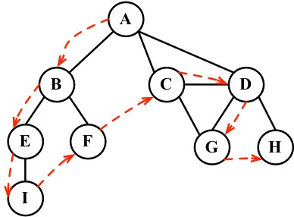
The DFS algorithm does not need a source vertex. In the DFS algorithm, for each unvisited vertex v in graph G, visit the vertex v.
To visit vertex v, perform the following:
- Mark v as discovered (grey).
- For all unvisited (white) neighbors w of v, visit vertex w and mark v as explored (black).
As you can note, the DFS steps are recursive, meaning the DFS algorithm uses a stack to store the calls (a stack created by the recursive calls).
Let's implement the DFS algorithm as follows:
this.dfs = function(callback){ var color = initializeColor(); //{1}
for (var i=0; i<vertices.length; i++){ //{2} if (color[vertices[i]] === 'white'){ //{3} dfsVisit(vertices[i], color, callback); //{4}
}
}
};
var dfsVisit = function(u, color, callback){
color[u] = 'grey'; //{5} if (callback) { //{6} callback(u);
}
var neighbors = adjList.get(u); //{7} for (var i=0; i<neighbors.length; i++){ //{8} var w = neighbors[i]; //{9} if (color[w] === 'white'){ //{10} dfsVisit(w, color, callback); //{11}
}
}
color[u] = 'black'; //{12} };
The first thing we need to do is create and initialize the color array (line {1}) with the value white for each vertex of the graph. We did the same thing for the BFS algorithm. Then, for each nonvisited vertex (lines {2} and {3}) of the Graph instance, we will call the recursive private function dfsVisit, passing the vertex, the color array, and the callback function (line {4}).
Whenever we visit the u vertex, we will mark it as discovered (grey, line {5}). If there is a callback function (line {6}), we will execute it to output the vertex visited. Then, the next step is getting the list of neighbors of the vertex u (line {7}). For each unvisited (the color white, lines {10} and {8}) neighbor w (line {9}) of u, we will call the dfsVisit function, passing w and the other parameters (line {11}, add the vertex w to the stack so it can be visited next). At the end, after the vertex and its adjacent vertices are visited deeply, we will backtrack, meaning the vertex is completely explored and is marked black (line {12}).
Let's test the dfs method by executing the following code: graph.dfs(printNode);
This will be its output:
Visited vertex: A
Visited vertex: B
Visited vertex: E
Visited vertex: I
Visited vertex: F
Visited vertex: C
Visited vertex: D
Visited vertex: G
Visited vertex: H
The order is the same as demonstrated by the diagram at the beginning of this section. The following diagram demonstrates the step-by-step process of the algorithm:
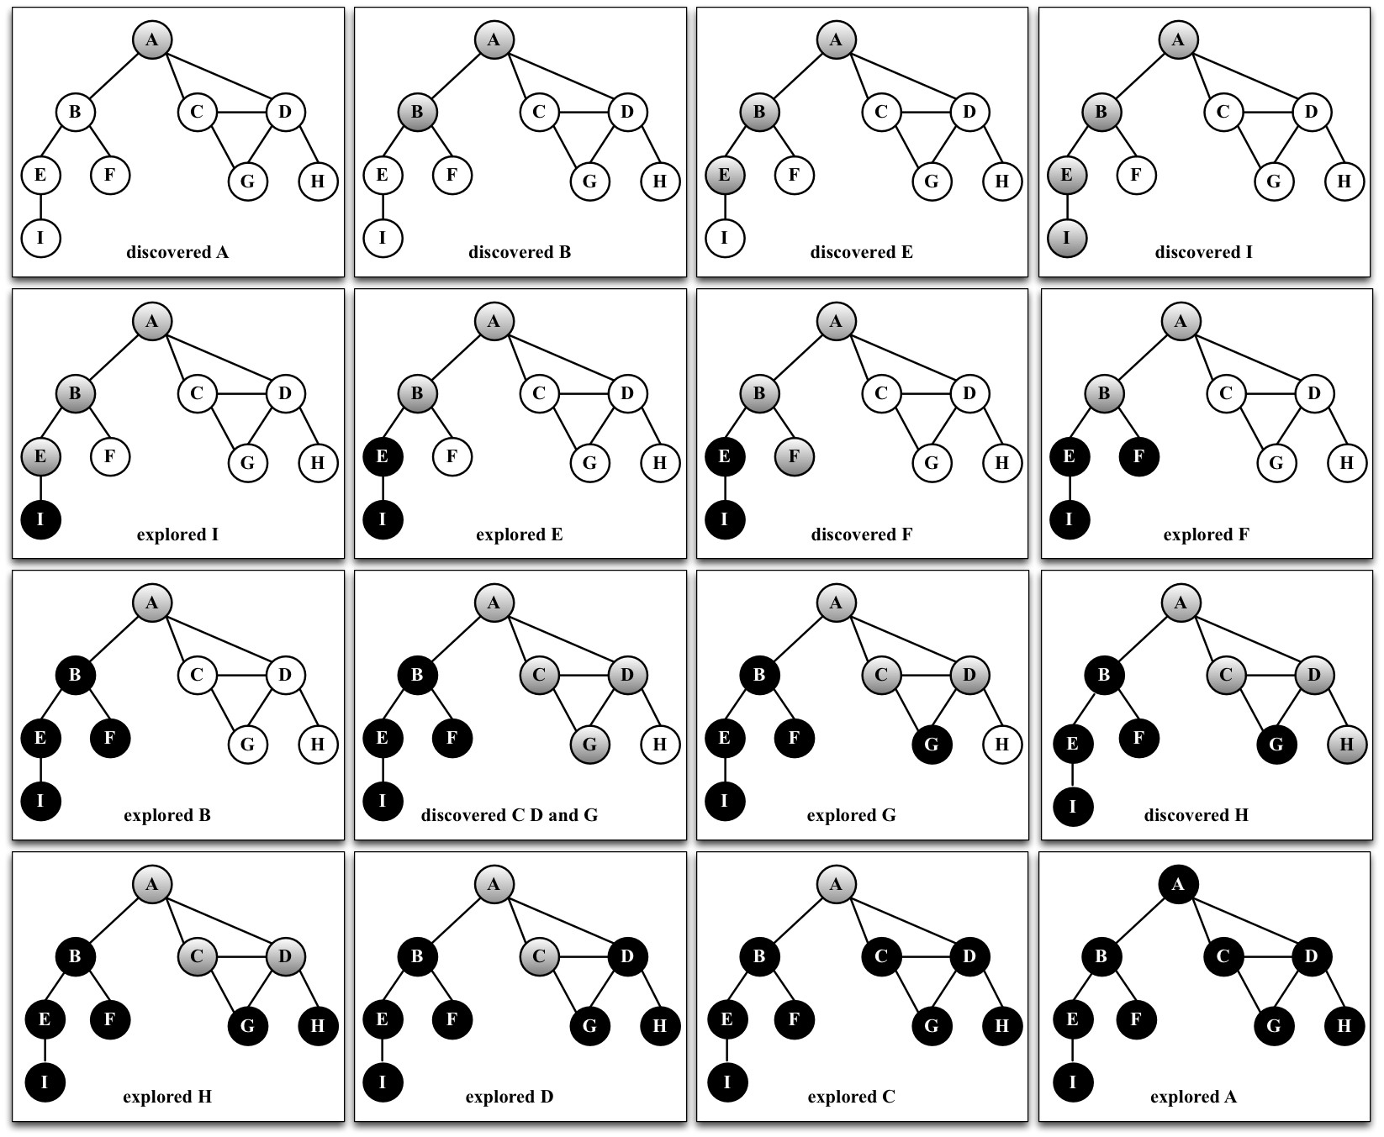
In this graph that we used as an example, line {4} will be executed only once, because all the other vertices have a path to the first one that is called the dfsVisit function (vertex A). If vertex B is the first one to call the function, then line {4} would be executed again for another vertex (for example, vertex A).

Exploring the DFS algorithm
So far, we have only demonstrated how the DFS algorithm works. We can use it for more functions than just outputting the order of vertices visited.
Given a graph G, the DFS algorithm traverses all the vertices of G and constructs a forest (a collection of rooted trees) together with a set of source vertices (roots) and outputs two arrays: the discovery time and finish explorer time. We can modify the dfs method to return some information for us, such as the following:
The discovery time d[u] of u
The finish time f[u] when u is marked black The predecessors p[u] of u
Let's take a look at the implementation of the improved BFS method:
var time = 0; //{1} this.DFS = function(){
var color = initializeColor(), //{2}
d = [], f = [], p = []; time = 0;
for (var i=0; i<vertices.length; i++){ //{3}
f[vertices[i]] = 0; d[vertices[i]] = 0; p[vertices[i]] = null;
}
for (i=0; i<vertices.length; i++){ if (color[vertices[i]] === 'white'){
DFSVisit(vertices[i], color, d, f, p);
}
}
return { //{4} discovery: d, finished: f, predecessors: p
};
};
var DFSVisit = function(u, color, d, f, p){
console.log('discovered ' + u);
color[u] = 'grey'; d[u] = ++time; //{5} var neighbors = adjList.get(u); for (var i=0; i<neighbors.length; i++){
var w = neighbors[i]; if (color[w] === 'white'){
p[w] = u; //{6}
DFSVisit(w,color, d, f, p);
}
}
color[u] = 'black'; f[u] = ++time; //{7} console.log('explored ' + u); };
As we want to track the time of discovery and the time when we finished exploring, we need to declare a variable to do this (line {1}). We cannot pass time as a parameter because variables that are not objects and cannot be passed as a reference to other JavaScript methods (passing a variable as a reference means that if this variable is modified inside the other method, the new values will also be reflected in the original variable). Next, we will declare the d, f, and p arrays, too (line {2}). We also need to initialize these arrays for each vertex of the graph (line {3}). At the end of the method, we will return these values (line {4}) so that we can work with them later.
When a vertex is first discovered, we will track its discovery time (line {5}). When it is discovered as an edge from u, we also keep track of its predecessor (line {6}). At the end, when the vertex is completely explored, we will track its finish time (line {7}).
What is the idea behind the DFS algorithm? The edges are explored out of the most recently discovered vertex u. Only the edges to nonvisited vertices are explored. When all the edges of u are explored, the algorithm backtracks to explore other edges where the vertex u was discovered. The process continues until we discover all the vertices that are reachable from the original source vertex. If any undiscovered vertices remain, we will repeat the process for a new source vertex. We will repeat the algorithm until all the vertices from the graph are explored.
There are two things that we need to check for the improved DFS algorithm:
The time variable can only have values from one to two times the number of vertices of the graph (2|V|)
For all the vertices u, d[u] < f[u] (meaning the discovered time needs to have a lower value than the finish time, which would in turn mean that all the vertices are explored)
With these two assumptions, we have the following rule:
1 ≤ d[u] < f[u] ≤ 2|V|
If we run the new DFS method for the same graph again, we will get the following discovery/finish time for each vertex of the graph:
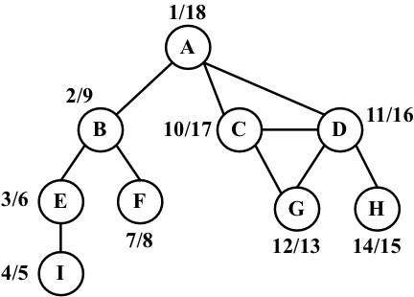
However, what can we do with this information? Let's consider this in the following section.

Topological sorting using DFS
Given the following graph, let's suppose each vertex is a task that you need to execute:
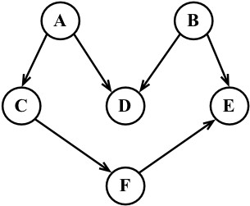
This is a directed graph, meaning there is an order that the tasks need to
be executed. For example, task
F
cannot be executed before task
A
. Note
that the previous graph also does not have a cycle, meaning it is an acyclic
graph. So, we can say that the previous graph is a
directed acyclic graph
(
DAG
).
When we need to specify the order that some tasks or steps need to be executed in, it is called topological sorting (or topsort or even toposort). This problem is present in different scenarios of our lives. For example, when we start a computer science course, there is an order of disciplines that we can take before taking any other discipline (you cannot take Algorithms II before taking Algorithms I). When we are working in a development project, there are some steps that need to be executed in order; for example, first we need to get the requirements from the client, then develop what is asked for by the client, and then deliver the project. You cannot deliver the project and gather the requirements after.
Topological sorting can only be applied to DAGs. So, how can we use topological sorting using DFS? Let's execute the DFS algorithm for the diagram presented at the beginning of this topic:
graph = new Graph();
myVertices = ['A','B','C','D','E','F']; for (i=0; i<myVertices.length; i++){ graph.addVertex(myVertices[i]);
}
graph.addEdge('A', 'C'); graph.addEdge('A', 'D'); graph.addEdge('B', 'D'); graph.addEdge('B', 'E'); graph.addEdge('C', 'F'); graph.addEdge('F', 'E'); var result = graph.DFS();
This code will create the graph, apply the edges, execute the improved DFS algorithm, and store the results inside the result variable. The following diagram demonstrates the discovery and finish time of the graph after DFS is executed:
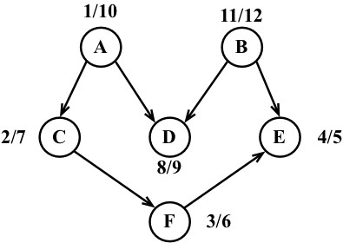
Now, all we have to do is sort the finishing time array and the decreasing order of finishing time, and we will have the topological sorting for the graph, as follows:
B - A - D - C - F - E
Note that the previous toposort result is only one of the possibilities. There might be different results if we modify the algorithm a little bit. For example, the following result is one of many other possibilities:
A - B - C - D - F - E
This could also be an acceptable result.

Shortest path algorithms
Given a map of streets, consider you want to get from point A to point B using the shortest path possible. We can use, as an example for this problem, the way from Santa Monica Blvd to Hollywood Blvd in Los Angeles, as demonstrated by the following image:
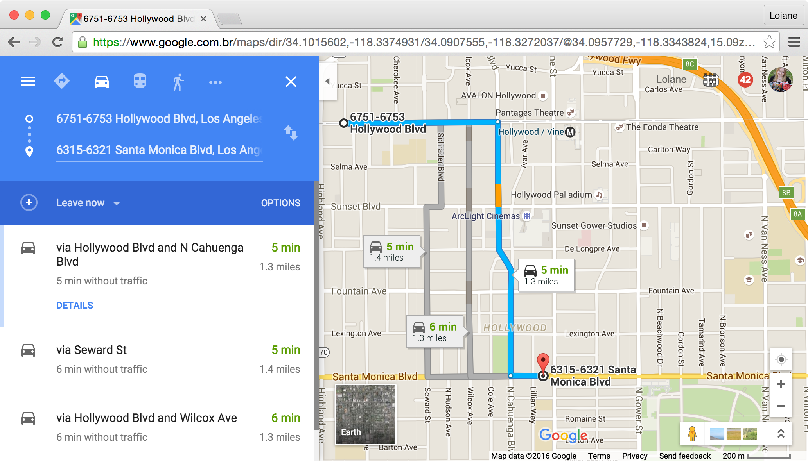
This is a very common problem in our lives, and we will use apps such as Apple or Google Maps and Waze to try to solve it, especially if you live in a big city. Of course, we also have other constraints involved, such as time or car traffic, but the original problem remains: how do we get from A to B using the shortest path?
We can use graphs to solve this problem for us, and the algorithm is called the shortest path. There are two algorithms that are very famous, which are Dijkstra's algorithm and Floyd-Warshall algorithm, which we will cover in the next topics.

Dijkstra's algorithm
Dijkstra's algorithm is a greedy algorithm (you will learn more about greedy algorithms in Chapter 11, Patterns of Algorithm) to calculate the shortest path between a single source and all the other sources, meaning we can use it to calculate the shortest path from a graph vertex to all the other vertices. Consider the following graph:
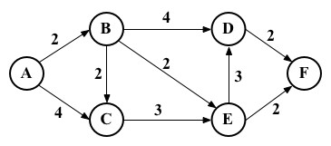
Let's take a look at how we can find the shortest path between the vertex A and all the other vertices. But first, we need to declare the adjacent matrix that represents the preceding graph, as follows:
var graph = [[0, 2, 4, 0, 0, 0], [0, 0, 1, 4, 2, 0],
[0, 0, 0, 0, 3, 0],
[0, 0, 0, 0, 0, 2],
[0, 0, 0, 3, 0, 2],
[0, 0, 0, 0, 0, 0]];
Now, let's consider how Dijkstra's algorithm works using the following code:
this.dijkstra = function(src){ var dist = [], visited = [], length = this.graph.length;
for (var i = 0; i < length; i++) { //{1}
dist[i] = INF; visited[i] = false;
}
dist[src] = 0; //{2} for (var i = 0; i < length-1; i++){ //{3} var u = minDistance(dist, visited); //{4} visited[u] = true; //{5}
for (var v = 0; v < length; v++){
if (!visited[v] &&
this.graph[u][v]!=0 && dist[u] != INF && dist[u]+this.graph[u][v] < dist[v]){ //{6} dist[v] = dist[u] + this.graph[u][v]; //{7}
}
}
}
return dist; //{8} };
The following is a description of how the algorithm works:
Line {1}: First, we need to initialize all distances (dist) as infinite (JavaScript max number INF = Number.MAX_SAFE_INTEGER) and visited[] as false
Line {2}: Second, we will set the distance of the source vertex from itself as
Line {3}: Then, we will find the shortest path for all vertices
Line {4}: To do so, we need to select the minimum distance vertex from the set of vertices that is not processed yet
Line {5}: We need to mark the selected vertex as visited so that we do not calculate twice
Line {6}: In case a shortest path is found, we will set the new value for the shortest path (line {7})
Line {8}: After all the vertices are processed, we will return the result containing the shortest path value from the vertex source (src) to all the other vertices of the graph
To calculate the minDistance between, we will search for the minimum value in the dist array, as follows, and return the array index that contains the minimum value:
var minDistance = function(dist, visited){ var min = INF, minIndex = -1;
for (var v = 0; v < dist.length; v++){ if (visited[v] == false && dist[v] <= min){
min = dist[v];
minIndex = v;
}
}
return minIndex; };
If we execute the preceding algorithm for the graph we presented at the beginning of the topic, we will have the following output:
- 0
- 2
- 3
- 6
- 4
- 6

It is also possible to modify the algorithm to return the value of the
shortest path and also the path.

The Floyd-Warshall algorithm
The Floyd-Warshall algorithm is a dynamic programming algorithm (you will learn more about dynamic programming in Chapter 11, Patterns of Algorithm) to calculate all the shortest paths on a graph. With this algorithm, we can find the shortest path from all the sources to all the vertices.
The Floyd-Warshall algorithm is given as follows:
this.floydWarshall = function(){
var dist = [], length = this.graph.length, i, j, k;
for (i = 0; i < length; i++){ //{1}
dist[i] = [];
for (j = 0; j < length; j++){ dist[i][j] = this.graph[i][j];
}
}
for (k = 0; k < length; k++){ //{2} for (i = 0; i < length; i++){ for (j = 0; j < length; j++){
if (dist[i][k] + dist[k][j] < dist[i][j]){ //{3} dist[i][j] = dist[i][k] + dist[k][j]; //{4}
}
}
}
}
return dist; };
The following is the description of how the algorithm works:
Line {1}: First, we will initiate the distance array with the value of the weight between each vertex as the minimum possible distance between i and j is the weight of these vertices
Line {2}: Using vertices 0...k as intermediate points, the shortest path between i and j is given through k
Line {3}: The formula used to calculate the shortest path between i and j through vertex k is given in line {3}
Line {4}: If a new value for the shortest path is found, we will use it
The formula on line {3} is the heart of the Floyd-Warshall algorithm. If we execute the preceding algorithm to the graph we exemplified at the beginning of the topic, we will have the following output:
0 2 3 6 4 6
INF 0 1 4 2 4
INF INF 0 6 3 5
INF INF INF 0 INF 2
INF INF INF 3 0 2
INF INF INF INF INF 0
Here, INF means that there is no shortest path between vertex i and j.
Another way of obtaining the same result would be to run Dijkstra's algorithm for each vertex of the graph.

Minimum spanning tree (MST)
The minimum spanning tree (MST) problem is very common in network designing. Imagine you have a business with several offices and want to connect the office's phone lines with each other with a minimum total cost to save money. Which is the best way of doing this?
This can also be applied to the island bridge problem. Consider you have an n number of islands and want to build bridges to connect each of them with a minimum cost.
Both the preceding problems can be solved with an MST algorithm, in which each office or island can be represented as a vertex of a graph, and the edges represent the cost. Here, we have an example of a graph where the thicker edges are a solution to MST:
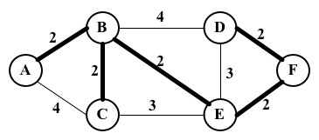
There are two main algorithms to find the minimal spanning trees: Prim's algorithm and Kruskal's algorithm, which you will learn in the following topics.

Prim's algorithm
Prim's algorithm is a greedy algorithm that finds an MST problem for a connected weighted undirected graph. It finds a subset of the edges that forms a tree that includes every vertex, where the total weight of all the edges in the tree is minimized.
Now, let's take a look at how Prim's algorithm works using the following code:
this.prim = function() {
var parent = [], key = [], visited = []; length = this.graph.length, i;
for (i = 0; i < length; i++){ //{1}
key[i] = INF; visited[i] = false; }
key[0] = 0; //{1} parent[0] = -1;
for (i = 0; i < length-1; i++) { //{3} var u = minKey(key, visited); //{4} visited[u] = true; //{5}
for (var v = 0; v < length; v++){ if (this.graph[u][v] && visited[v] == false && this.graph[u][v] < key[v]){ //{6} parent[v] = u; //{7} key[v] = this.graph[u][v]; //{8}
}
}
}
return parent; //{9} };
The following is a description of how the algorithm works:
Line {1}: First, we need to initialize all the keys vertices as infinite (JavaScript max number INF = Number.MAX_SAFE_INTEGER) and visited[] as false
Line {2}: Second, we will set the first key as so that this vertex is picked as the first vertex and parent[0] = -1 because the first node is always the root of
MST
Line {3}: Then, we will find MST for all vertices
Line {4}: To do so, we need to select the minimum key vertex from the set of vertices that was not processed yet (the same function as we used in Dijkstra's algorithm but with a different name)
Line {5}: We need to mark the selected vertex as visited so that we do not calculate it twice
Line {6}: In case a minimum weight is found, we will store the MST path value
(parent, line {7}) and set the new cost for the MST value (line {8})
Line {9}: After all the vertices are processed, we will return the result containing the MST

If we compare Prim's algorithm with Dijkstra's algorithm, we will see that they are very similar, with the exception of lines {7} and {8}. Line {7} keeps the parent array, which is the array that stores the MST. Line {8} stores the minimum edge value, while in Dijkstra's algorithm, the distance array is used instead of the key array to store the distance. We can modify Dijkstra's algorithm to add to the parent array, and this way, we can track the path along with its distance value.
Let's now execute the preceding algorithm for the following graph:
var graph = [[0, 2, 4, 0, 0, 0], [2, 0, 2, 4, 2, 0],
[4, 2, 0, 0, 3, 0],
[0, 4, 0, 0, 3, 2],
[0, 2, 3, 3, 0, 2],
[0, 0, 0, 2, 2, 0]];
We will have the following output:
Edge Weight
- - 1 2
- - 2 2
5 - 3 2
1 - 4 2
4 - 5 2

Kruskal's algorithm
Similarly to Prim's algorithm, Kruskal's algorithm is also a greedy algorithm that finds MST for a connected weighted undirected graph.
Let's consider how Kruskal's algorithm works using the following code:
this.kruskal = function(){ var length = this.graph.length,
parent = [], cost, ne = 0, a, b, u, v, i, j, min; cost = initializeCost(); //{1} while(ne<length-1) { //{2}
for(i=0, min = INF;i < length; i++) { //{3}
for(j=0;j < length; j++) { if(cost[i][j] < min) { min=cost[i][j]; u = i; v = j;
}
}
}
u = find(u, parent); //{4} v = find(v, parent); //{5}
if (union(u, v, parent)){ //{6}
ne++; }
cost[u][v] = cost[v][u] = INF; //{7}
}
return parent;
}
The following is a description of how the algorithm works:
Line {1}: First, we will copy the adjacent matrix values to the cost array so that we can modify it without loosing the original values (line {7})
Line {2}: While MST has fewer than total edges -1
Line {3}: Find edge with minimum cost
Lines {4} and {5}: To avoid cycles, verify that the edge is already in MST
Line {6}: If edges u and v are not the same, then add it to MST
Line {7}: Remove the edges from the list so that we do not calculate it twice Line {8}: Return MST
The find function is given as follows. It prevents cycles in MST:
var find = function(i, parent){
while(parent[i]){ i = parent[i];
} return i; };
The union function is also given here:
var union = function(i, j, parent){
if(i != j) { parent[j] = i; return true;
}
return false; };
There are a few variations of this algorithm that can be developed. It will depend on the data structure used to sort the weight the edges values (such as Priority Queue) and also how the graph is represented.

Summary
In this chapter, we covered the basic concepts of graphs. You learned the different ways we can represent this data structure, and we implemented an algorithm to represent a graph using an adjacency list. You also learned how to traverse a graph using BFS and DFS approaches. This chapter also covered two applications of BFS and DFS, which find the shortest path using BFS and topological sorting using DFS.
This chapter also covered some famous algorithms such as Dijkstra's algorithm and the Floyd-Warshall algorithm to calculate the shortest path. We also covered Prim's algorithm and Kruskal's algorithm to calculate the minimum spanning tree of the graph.
In the next chapter, you will learn the most common sorting algorithms used in computer science.

Sorting and Searching10
Algorithms
Suppose we have a telephone agenda (or a notebook) that does not have any sorting order. When you need to add a contact with telephone numbers, you simply write it down in the next available slot. Suppose you also have a high number of contacts in your contact list. On any ordinary day, you need to find a particular contact and his/her telephone number. However, as the contact list is not organized in any order, you have to check it contact by contact until you find the desired one. This approach is horrible, don't you agree? Imagine that you have to search for a contact in Yellow Pages and it is not organized! It could take forever!
For this reason, among others, we need to organize sets of information, such as the information we have stored in data structures. Sorting and searching algorithms are widely used in the daily problems we have to solve.
In this chapter, you will learn about the most commonly used sorting and searching algorithms, such as the bubble sort, selection sort, insertion sort, merge sort, quick sort, and heap sort as well as the sequential and binary search algorithms.

The sorting algorithms
From this introduction, you should understand that you need to learn how to sort first and then search for the information given. In this section, we will cover some of the most wellknown sorting algorithms in computer science. We will start with the slowest one, and then we will cover some better algorithms.
Before we get started with the sorting algorithms, let's create an array (list) to represent the data structure that we want to sort and search, as follows:
function ArrayList(){ var array = []; //{1}
this.insert = function(item){ //{2}
array.push(item); };
this.toString= function(){ //{3}
return array.join();
};
}
As you can note, ArrayList is a simple data structure that stores the items in an array (line {1}). We only have an insert method to add elements to our data structure (line {2}), which simply uses the native push method of the JavaScript Array class that we covered in Chapter 2, Arrays. Finally, to help us verify the result, the toString method (line {3}) concatenates all the array's elements into a single string so that we can easily output the result in the browser's console using the join method from the native JavaScript Array class.

The
join
method joins the elements of an array into a string and returns
the string.
Note that this ArrayList class does not have any method to remove data or insert it into specific positions. We want to keep it simple so that we can focus on the sorting and searching algorithms. We will add all the sorting and searching methods to this class.
Now, we can get started!

The bubble sort
When people first start learning sorting algorithms, they usually learn the bubble sort algorithm first, because it is the simplest of all the sorting algorithms. However, it is one of the worst-case sorting algorithms with respect to runtime, and you will see why.
The bubble sort algorithm compares every two adjacent items and swaps them if the first one is bigger than the second one. It has this name because the items tend to move up into the correct order, like bubbles rising to the surface.
Let's implement the bubble sort algorithm as follows:
this.bubbleSort = function(){
var length = array.length; //{1} for (var i=0; i<length; i++){ //{2} for (var j=0; j<length-1; j++ ){ //{3} if (array[j] > array[j+1]){ //{4} swap(array, j, j+1); //{5}
}
}
}
};
First, let's declare a variable called length, which will store the size of the array (line {1}). This step will help us to get the size of the array on lines {2} and {3}, and this step is optional. Then, we will have an outer loop (line {2}) that will iterate the array from its first position to the last one, controlling how many passes are done in the array (which should be one pass per item of the array as the number of passes is equal to the size of the array). Then, we have an inner loop (line {3}) that will iterate the array starting from its first position to the penultimate item that will actually do the comparison between the current item and the next one (line {4}). If the items are out of order (that is, the current one is bigger than the next one), then we will swap them (line {5}), meaning that the value of the j+1 position will be transferred to the j position and vice versa.
Now, we need to declare the swap function (a private function that is available only to the code inside the ArrayList class):
var swap = function(array, index1, index2){
var aux = array[index1]; array[index1] = array[index2];
array[index2] = aux; };
To make the swap, we need a temporary variable to store the value of one of the items in. We will use this method for other sorting methods as well, and this is the reason we will declare this swap code into a function so that we can reuse it.
If we use ES6 (ECMAScript 2015), we can replace the preceding function with the following
code (which uses the enhanced object properties that you learned in Chapter 1, JavaScript—A Quick Overview):
[array[index1], array[index2]] = [array[index2], array[index1]];
The following diagram illustrates the bubble sort in action:
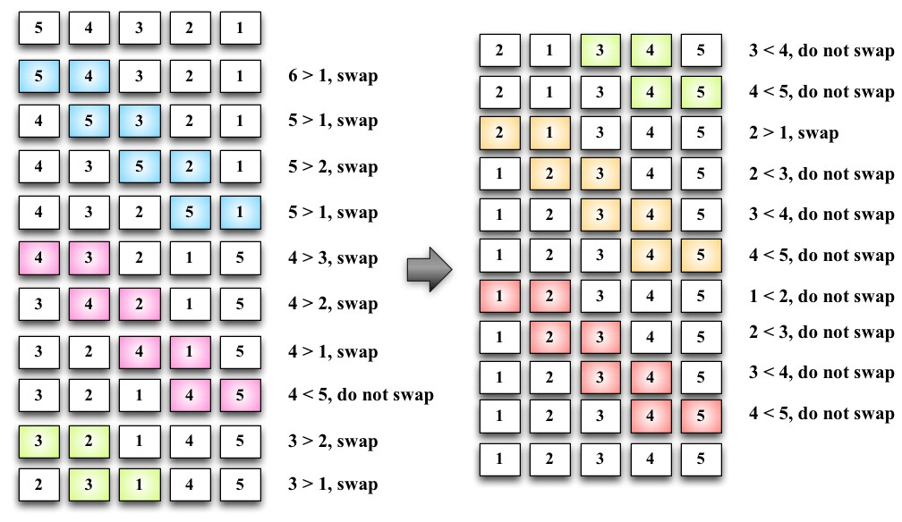
Each different section in the preceding diagram represents a pass made by the outer loop (line {2}), and each comparison between two adjacent items is made by the inner loop (line {3}).
To test the bubble sort algorithm and get the same results shown by the diagram, we will use the following code:
function createNonSortedArray(size){ //{6}
var array = new ArrayList(); for (var i = size; i> 0; i--){
array.insert(i);
}
return array; }
var array = createNonSortedArray(5); //{7} console.log(array.toString()); //{8} array.bubbleSort(); //{9} console.log(array.toString()); //{10}
To help us test the sorting algorithms that you will learn in this chapter, we will create a function that will automatically create a nonsorted array with the size that is passed by the parameter (line {6}). If we pass 5 as the parameter, the function will create the following array for us: [5, 4, 3, 2, 1]. Then, all we have to do is call this function and store its return value in a variable that contains the instance of the ArrayList class initialized with some numbers (line {7}). Just to make sure we have an unsorted array, we will output the array's content on console (line {8}), call the bubble sort method (line {9}), and output the array's content on console again so that we can verify that the array was sorted (line {10}).

You can find the complete source code of the ArrayList class and the testing code (with additional comments) on the source code that you downloaded from the support page (or from the GitHub repository).
Note that when the algorithm executes the second pass of the outer loop (the second section of the previous diagram), the numbers 4 and 5 are already sorted. Nevertheless, on subsequent comparisons, we will keep comparing them even if the comparison is not needed. For this reason, we will make a small improvement on the bubble sort algorithm.

The improved bubble sort
If we subtract the number of passes from the inner loop, we will avoid all the unnecessary comparisons made by the inner loop (line {1}):
this.modifiedBubbleSort = function(){ var length = array.length; for (var i=0; i<length; i++){ for (var j=0; j<length-1-i; j++ ){ //{1}
if (array[j] > array[j+1]){
swap(j, j+1);
}
}
}
};
The following diagram exemplifies how the improved bubble sort works:
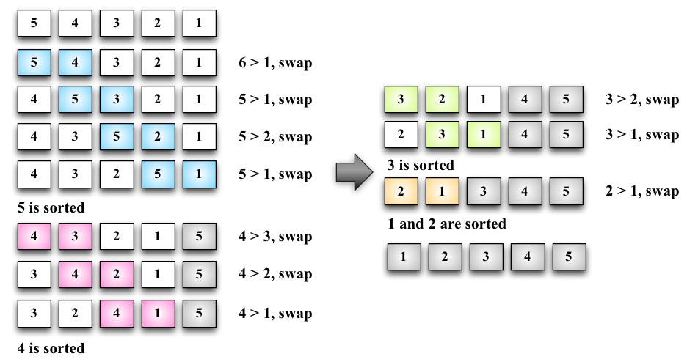
Note that we did not compare the numbers that are already in place. Even
though we made this small change to improve the bubble sort algorithm a
little bit, it is not a recommended algorithm. It has a complexity of
O(n
2
)
.
We will talk more about the big O notation in Chapter 12, Algorithm complexity, to learn more about algorithms.

The selection sort
The selection sort algorithm is an in-place comparison sort algorithm. The general idea of the selection sort is to find the minimum value in the data structure, place it in the first position, then find the second minimum value, place it in the second position, and so on.
The following is the source code for the selection sort algorithm:
this.selectionSort = function(){ var length = array.length, //{1}
indexMin;
for (var i=0; i<length-1; i++){ //{2} indexMin = i; //{3} for (var j=i; j<length; j++){ //{4} if(array[indexMin]>array[j]){ //{5} indexMin = j; //{6}
}
}
if (i !== indexMin){ //{7}
swap(i, indexMin);
}
}
};
First, we will declare some of the variables that we will use in the algorithm (line {1}). Then, we have an outer loop (line {2}) that will iterate the array and control the passes (that is, which n^{th} value of the array we need to find next or the next min value). We will assume that the first value of the current pass is the minimum value of the array (line {3}). Then, starting from the current i value to the end of the array (line {4}), we will compare whether the value in the j position is less than the current minimum value (line {5}); if this is true, we will change the value of the minimum to the new minimum value (line {6}). When we get out of the inner loop (line {4}), we will have the n^{th} minimum value of the array. Then, if the minimum value is different from the original minimum value (line {7}), we will swap them.
To test the selection sort algorithm, we can use the following code:
array = createNonSortedArray(5); console.log(array.toString()); array.selectionSort(); console.log(array.toString());
The following diagram exemplifies the selection sort algorithm in action based on our array, which is used in the preceding code [5, 4, 3, 2, 1]:
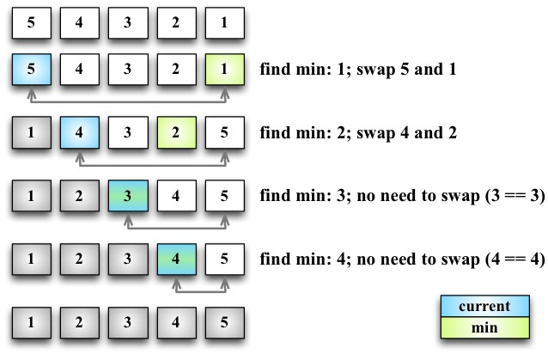
The arrows at the bottom of the array indicate the positions currently in consideration to find the minimum value (inner loop: line {4}), and each step of the preceding diagram represents the outer loop (line {2}).
The selection sort is also an algorithm of complexity O(n²). Similar to the bubble sort, it contains two nested loops that are responsible for the quadratic complexity. However, the selection sort performs worse than the insertion sort algorithm that you will learn next.

The insertion sort
The insertion sort algorithm builds the final sorted array one item at a time. It assumes that the first element is already sorted. Then, a comparison with the second item is performed: should the second item stay in its place or be inserted before the first item? So, the first two items will get sorted, he comparison will take place with the third item (that is, should it be inserted in the first, second, or third position?), and so on.
The following code represents the insertion sort algorithm:
this.insertionSort = function(){ var length = array.length, //{1}
j, temp;
for (var i=1; i<length; i++){ //{2} j = i; //{3} temp = array[i]; //{4} while (j>0 && array[j-1] > temp){ //{5} array[j] = array[j-1]; //{6}
j--;
}
array[j] = temp; //{7}
}
};
As usual, the first line of the algorithm is used to declare the variables we will use in the source code (line {1}). Then, we will iterate the array to find the correct place for the i^{th} item (line {2}). Note that we started from the second position (index 1), instead of position 0 (as we considered the first item already sorted). Then, we initiated an auxiliary variable with the value of i (line {3}), and we also stored the value in a temporary value (line {4}) so that we can insert it in the correct position later. The next step is finding the correct place to insert the item. As long as the j variable is bigger than (because the first index of the array is and there is no negative index) and the previous value in the array is bigger than the value we are comparing (line {5}), we will shift the previous value to the current position (line {6}) and decrease the value of j. At the end, we will insert the value in its correct position.
The following diagram exemplifies the insertion sort in action:
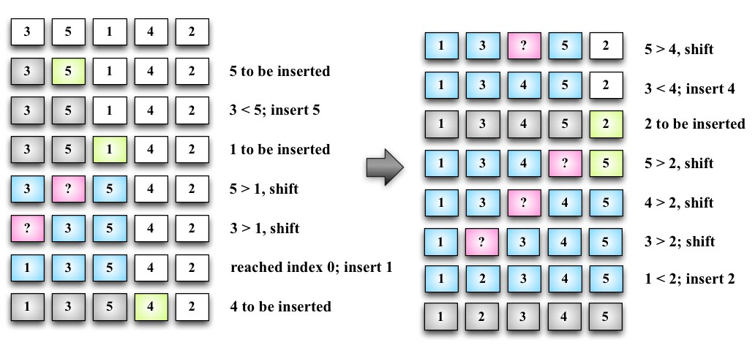
For example, suppose the array we are trying to sort is [3, 5, 1, 4, 2]. These values will be carried out in the steps performed by the insertion sort algorithm, as described in the following steps:
- The value 3 is already sorted, so we will start sorting the second value of the array, which is the value 5. The value 3 is less than the value 5, so 5 stays in the same place (meaning the second position of the array). The values 3 and 5 are already sorted.
- The next value to be sorted and inserted in the correct place is 1 (which is currently in the third position of the array). The value 5 is greater than 1, so 5 is shifted to the third position. We need to analyze whether 1 should be inserted in the second position—is 1 greater than 3? It's not, so the value 3 gets shifted to the second position. Next, we need to verify that 1 is inserted in the first position of the array. As 0 is the first position and there isn't a negative position, 1 needs to be inserted on the first position. The values 1, 3, and 5 are sorted.
- We move to the next value: 4. Should the value 4 stay in the current position
(index 3), or does it need to be moved to a lower position? The value 4 is less than 5, so 5 will get shifted to index 3. Should we insert 4 in the index 2? The value 4 is greater than 3, so 4 is inserted in position 3 of the array.
- The next value to be inserted is 2 (position 4 of array). The value 5 is greater than 2, so 5 gets shifted to the index 4. The value 4 is greater than 2, so 4 will also get shifted (position 3). The value 3 is also greater than 2, and 3 also gets shifted. The value 1 is less than 2, so 2 is inserted at the second position of the array. Thus, the array is sorted.
This algorithm has a better performance than the selection and bubble sort algorithms when sorting small arrays.

The merge sort
The merge sort algorithm is the first sorting algorithm that can be used in the real world. The three first sorting algorithms that you learned in this book do not give good performance, but the merge sort gives a good performance with a complexity of O(n log n).
The JavaScript Array class defines a sort function
(Array.prototype.sort) that can be used to sort arrays using JavaScript

(with no need to implement the algorithm ourselves). ECMAScript does not define which sorting algorithm needs to be used, so each browser can implement its own algorithm. For example, Mozilla Firefox uses the merge sort as the Array.prototype.sort implementation, while Chrome uses a variation of the quick sort (which you will learn next).
The merge sort is a divide-and-conquer algorithm. The idea behind it is to divide the original array into smaller arrays until each small array has only one position and then merge these smaller arrays into bigger ones until we have a single big array at the end that is sorted.
Because of the divide-and-conquer approach, the merge sort algorithm is also recursive, as follows:
this.mergeSort = function(){ array = mergeSortRec(array); };
As in the previous chapters, whenever we implement a recursive function, we always implement a helper function that will be executed. For the merge sort, we will do the same. We will declare the mergeSort method that will be available for use, and the mergeSort method will call mergeSortRec, which is a recursive function:
var mergeSortRec = function(array){ var length = array.length; if(length === 1) { //{1} return array; //{2}
}
var mid = Math.floor(length / 2), //{3} left = array.slice(0, mid), //{4} right = array.slice(mid, length); //{5}
return merge(mergeSortRec(left), mergeSortRec(right)); //{6} };
The merge sort will transform a bigger array into smaller arrays until they have only one item in them. As the algorithm is recursive, we need a stop condition—that is, if the array has a size equal to 1 (line {1}). If positive, we will return the array with size 1 (line {2}) because it is already sorted.
If the array is bigger than 1, then we will split it into smaller arrays. To do so, first we need to find the middle of the array (line {3}), and once we find the middle, we will split the array into two smaller arrays, which we will call left (line {4}) and right (line {5}). The left array comprises of elements from index 0 to the middle index, and the right array consists of elements from the middle index to the end of the original array.
The next steps will be to call the merge function (line {6}), which will be responsible for merging and sorting the smaller arrays into bigger ones until we have the original array sorted and back together. To keep breaking the original array into smaller pieces, we will recursively call mergeSortRec again, passing the smaller array to the left as a parameter and another call for the array to the right. Execute the following code:
var merge = function(left, right){ var result = [], // {7}
il = 0, ir = 0;
while(il < left.length && ir < right.length) { // {8}
if(left[il] < right[ir]) { result.push(left[il++]); // {9}
} else{
result.push(right[ir++]); // {10}
}
}
while (il < left.length){ // {11}
result.push(left[il++]); }
while (ir < right.length){ // {12} result.push(right[ir++]); }
return result; // {13} };
The merge function receives two arrays and merges them into a bigger array. During the merge is when the sorting happens. First, we need to declare a new array that will be created for the merge and also declare two variables (line {7}) that will be used to iterate the two arrays (the left and right arrays). While we can iterate through the two arrays (line {8}), we will compare whether the item from the left array is less than the item from the right array. If positive, we will add the item from the left array to the merged result array and also increment the variable that is used to iterate the array (line {9}); otherwise, we will add the item from the right array and increment the variable that is used to iterate the array (line {10}).
Next, we will add every remaining item from the left array (line {11}) to the merged result array and do the same for the remaining items from the right array (line {12}). At the end, we will return a merged array as the result (line {13}).
If we execute the mergeSort function, this is how it will be executed:
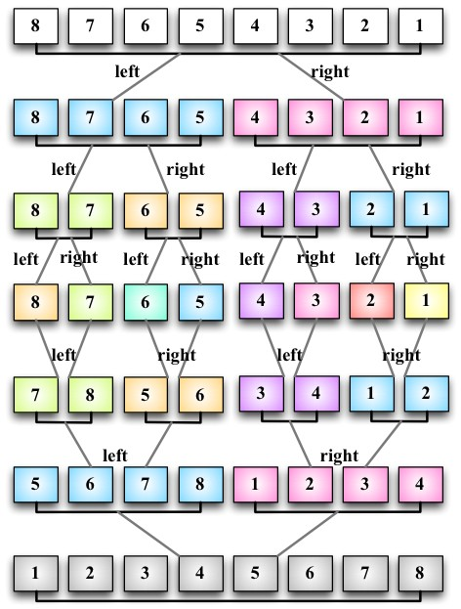
Note that first the algorithm splits the original array until it has smaller arrays with a single element, and then it starts merging. While merging, it does the sorting as well until we have the original array completely back together and sorted.

The quick sort
The quick sort is probably the most used sorting algorithm. It has a complexity of O(n log n), and it usually performs better than other O(n log n) sorting algorithms. Similarly to the merge sort, it also uses the divide-and-conquer approach, dividing the original array into smaller ones (but without splitting them as the merge sort does) to do the sorting.
The quick sort algorithm is a little bit more complex than the other ones you have learned so far. Let's learn it step by step, as follows:
- First, we need to select an item from the array called pivot, which is the middle item in the array.
- We will create two pointers—the left-hand side one will point to the first item of the array, and the right-hand side one will point to the last item of the array. We will move the left pointer until we find an item that is bigger than the pivot, and we will also move the right pointer until we find an item that is less than the pivot and swap them. We will repeat this process until the left-hand side pointer passes the right-hand side pointer. This process helps to have values lower than the pivot before the pivot and values greater than the pivot after the pivot. This is called the partition operation.
- Next, the algorithm repeats the previous two steps for smaller arrays (subarrays with smaller values and then subarrays with greater values) until the arrays are completely sorted.
Let's start the implementation of the quick sort via the following code:
this.quickSort = function(){ quick(array, 0, array.length - 1); };
Similarly to the merge sort, we will start declaring the main method that will call the recursive function, passing the array that we want to sort along with index 0 and its last position (because we want to have the whole array sorted, not only a subset of it), as follows:
var quick = function(array, left, right){ var index; //{1} if (array.length > 1) { //{2} index = partition(array, left, right); //{3}
if (left < index - 1) { //{4} quick(array, left, index - 1); //{5} }
if (index < right) { //{6} quick(array, index, right); //{7}
}
}
};
First, we will have the index variable (line {1}), which will help us separate the subarray with smaller and greater values so that we can recursively call the quick function again.
We will obtain the index value as the return value of the partition function (line {3}).
If the size of the array is larger than 1 (because an array with a single element is already sorted at line {2}), we will execute the partition operation on the given subarray (the first call will pass the complete array) to obtain index (line {3}). If a subarray with smaller elements exists (line {4}), we will repeat the process for the subarray (line {5}). We will do the same thing for the subarray with greater values. If there is any subarray with a greater value (line {6}), we will repeat the quick sort process (line {7}) as well.

The partition process
The first thing we need to do is choose the pivot element. There are a few ways in which we can do this. The simplest one is selecting the first item of the array (the leftmost item). However, studies show that this is not a good selection if the array is almost sorted, causing the worst behavior of the algorithm. Another approach is selecting a random item of the array or the middle item.
Now, let's take a look at the partition process:
var partition = function(array, left, right) {
var pivot = array[Math.floor((right + left) / 2)], //{8} i = left, //{9} j = right; //{10}
while (i <= j) { //{11} while (array[i] < pivot) { //{12}
i++;
}
while (array[j] > pivot) { //{13}
j--;
}
if (i <= j) { //{14} swap(array, i, j); //{15}
i++; j--;
}
}
return i; //{16}
};
For this implementation, we will select the middle item as pivot (line {8}). We will also initiate the two pointers: left (low at line {9}) with the first element of the array and right (high at line {10}) with the last element of the array.
While the left and right pointers do not cross each other (line {11}), we will execute the partition operation. First, until we find an element that is greater than pivot (line {12}), we will shift the left pointer. We will do the same with the right pointer until we find an element that is less than pivot, and we will shift the right pointer as well (line {13}).
When the left pointer is greater than pivot and the right pointer is lower than pivot, we will compare whether the left pointer index is bigger than the right pointer index (line {14}), meaning whether the left item is greater than the right item (in value). We will swap these (line {15}), shift both the pointers, and repeat the process (starting again at line {11}).
At the end of the partition operation, we will return the index of the left pointer that will be used to create the subarrays in line {3}.
The swap function is the same we created for the bubble sort algorithm at the beginning of this chapter. We can also replace this function with the following ES6 code:
[array[index1], array[index2]] = [array[index2], array[index1]];

The quick sort in action
Let's take a look at the quick sort algorithm in action step by step:
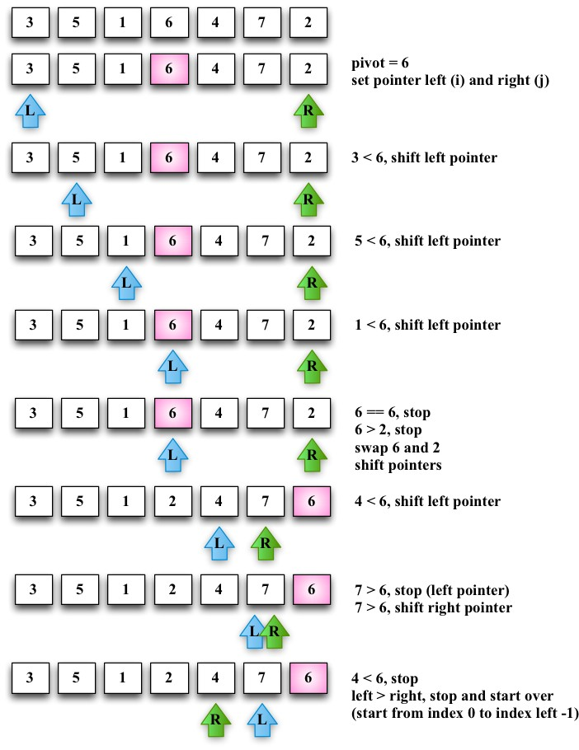
Given the [3, 5, 1, 6, 4, 7, 2] array, the preceding diagram represents the first execution of the partition operation.
The following diagram exemplifies the execution of the partition operation for the first subarray of lower values (note that 7 and 6 are not part of the subarray):
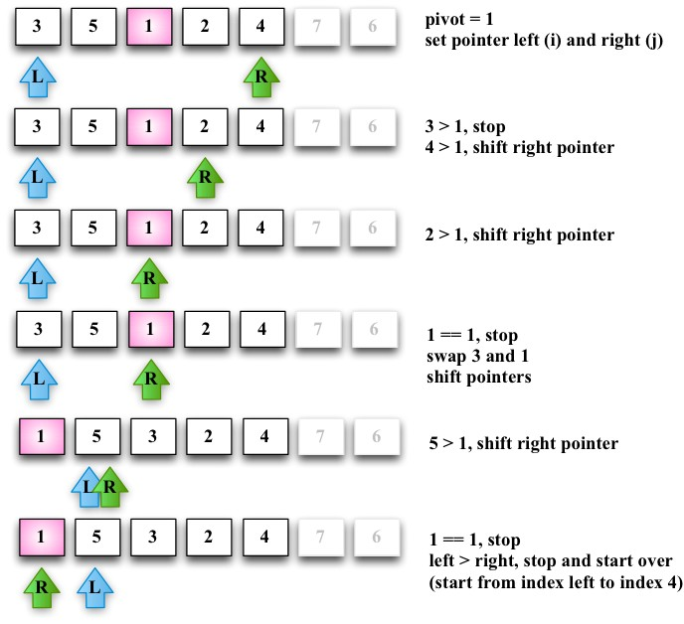
Next, we will continue creating subarrays, as seen in the following diagram but now with greater values than the subarray of the preceding diagram (the lower subarray with value 1 does not need to be partitioned because it only contains one item):
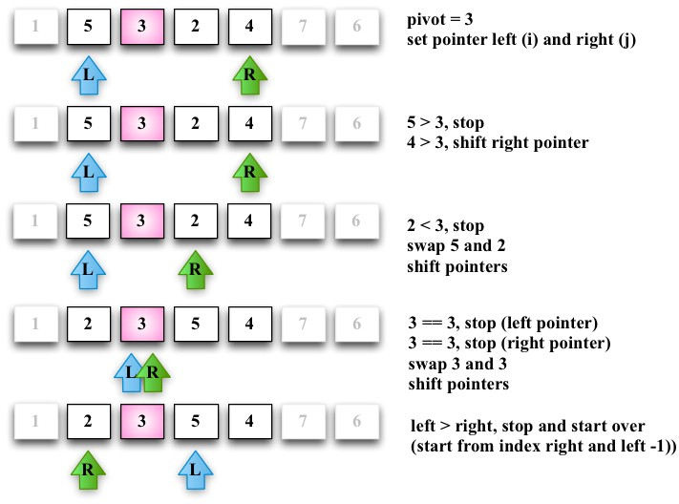
The lower subarray [2, 3] from the ([2, 3, 5, 4]) subarray continues to be partitioned (line {5} from the algorithm):
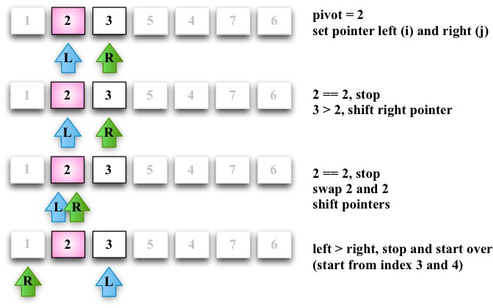
Then, the greater subarray [5, 4] from the [2, 3, 5, 4] subarray also continues to be partitioned (line {7} from the algorithm), as shown in the following diagram:
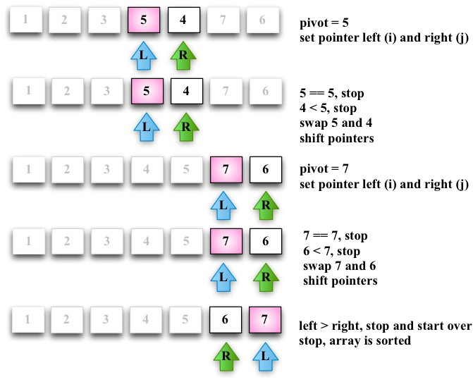
At the end, the greater subarray [6, 7] will also suffer the partition operation, completing the execution of the quick sort algorithm.

The heap sort
The heap sort is another efficient algorithm. The algorithm has this name because it sorts the array as if it were a binary tree. To do so, we need to manage the array as a binary tree considering the following information:
Index 0 is the root of the tree
The parent of any node N is N/2 (with the exception of the root node)
The left-hand side child of a node L is 2*L The right-hand child of a node R is 2*R+1
So for example, we can consider the [3,5,1,6,4,7,2] array as the following tree:
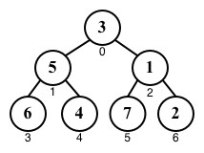
The heap sort algorithm is given as follows:
this.heapSort = function(){ var heapSize = array.length; buildHeap(array); //{1}
while (heapSize > 1) { heapSize--;
swap(array, 0, heapSize); //{2} heapify(array, heapSize, 0); //{3}
}
};
The first step is to build the heap structure (line {1}) in a way that array[parent(i)] ≥ array[i].
Then, as the second step, we will swap the first position (the bigger value in the array) with the last position of the current heap (line {2}). This way, the biggest value will be placed at its sorted position.
Step {2} might cancel the heap property. For this reason, we need to run a function called heapify that will transform the array into a heap again, meaning it will get the root of the current heap (the smaller value) and push it into the bottom of the tree again.
The buildHeap function is given as follows:
var buildHeap = function(array){ var heapSize = array.length;
for (var i = Math.floor(array.length / 2); i >= 0; i--) {
heapify(array, heapSize, i);
}
};
If we apply the preceding function to the [3,5,1,6,4,7,2] array, we will have the following steps until the heap is built:
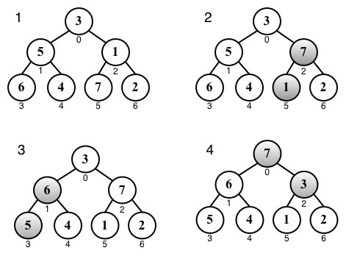
Finally, we will have the heapify function similar to the following:
var heapify = function(array, heapSize, i){
var left = i * 2 + 1, right = i * 2 + 2, largest = i;
if (left < heapSize && array[left] > array[largest]) {
largest = left; }
if (right < heapSize && array[right] > array[largest]) {
largest = right;
}
if (largest !== i) { swap(array, i, largest); heapify(array, heapSize, largest);
}
};
After the heap is ready, we can start the heap sort algorithm. These will be the steps {2} and {3} applied to the array.
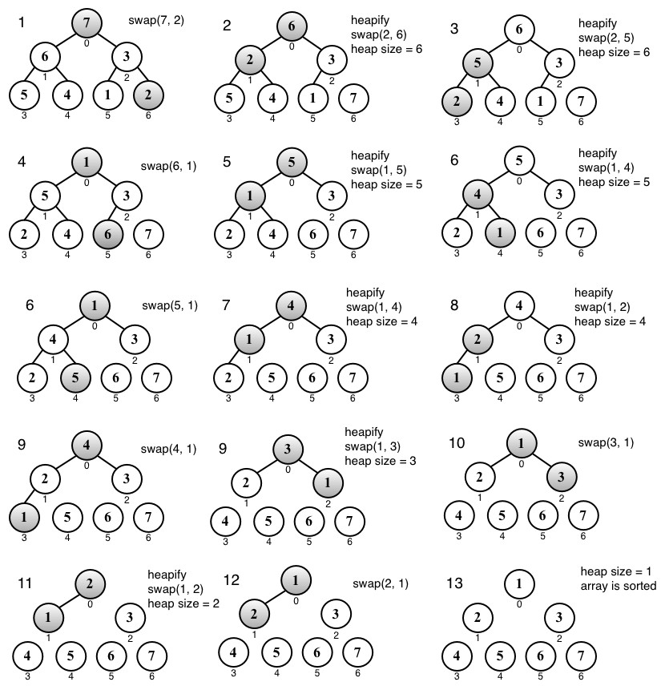

The counting, bucket, and radix sorts (the distribution sorts)
So far, you have learned how to sort an array without using any auxiliary data structure. There is also another type of sorting algorithm called the distribution sort in which the data is distributed from the original array in multiple intermediate structures (buckets), which are then gathered and placed on the original array.
The most famous distribution algorithms are the counting sort, bucket sort, and radix sort. These three algorithms are very similar.

We will not cover these algorithms in this book. However, you can find the algorithms and examples within the source code bundle of this book or in the Github repository
at https://github.com/loiane/javascript-datastructures-algo rithms.

Searching algorithms
Now, let's talk about searching algorithms. If we take a look at the algorithms we implemented in previous chapters, such as the search method of the BinarySearchTree class (Chapter 8, Trees) or the indexOf method of the LinkedList class (Chapter 5, Linked Lists), these are all search algorithms, and of course, each one was implemented according to the behavior of its data structure. So we are already familiar with two-search algorithm; we just do not know their “official” names yet!

The sequential search
The sequential or linear search is the most basic search algorithm. It consists of comparing each element of the data structure with the one we are looking for. It is also the most inefficient one.
Let's take a look at its implementation:
this.sequentialSearch = function(item){ for (var i=0; i<array.length; i++){ //{1} if (item === array[i]){ //{2} return i; //{3}
}
}
return -1; //{4} };
The sequential search iterates through the array (line {1}) and compares each item with the value we are searching for (line {2}). If we find it, we can return something to indicate that we found it. We can return the item itself, the value true, or its index (line {3}). In the preceding implementation, we returned the index of the item. If we don't find the item, we can return -1 (line {4}), indicating that the index does not exist; the values false and null are among other options.
Suppose we have the [5, 4, 3, 2, 1] array and we are looking for the value 3, then the following diagram shows the steps of the sequential search:
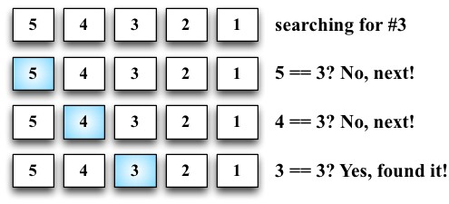

The binary search
The binary search algorithm works similar to the number guessing game, in which someone says “I'm thinking of a number between 1 and 100”. We will begin by responding with a number, and the person will say “higher”, “lower”, or that we got it right.
To make the algorithm work, the data structure needs to be sorted first. These are the steps that the algorithm follows:
- A value is selected in the middle of the array.
- If the item is the one we are looking for, we are done (the value is right).
- If the value we are looking for is less than the selected one, then we will go to the left and back to 1 (lower).
- If the value we are looking for is larger than the selected one, then we will go to the right and back to 1 (higher).
Let's take a look at its implementation:
this.binarySearch = function(item){ this.quickSort(); //{1}
var low = 0, //{2} high = array.length - 1, //{3} mid, element;
while (low <= high){ //{4}
mid = Math.floor((low + high) / 2); //{5} element = array[mid]; //{6} if (element < item) { //{7} low = mid + 1; //{8} } else if (element > item) { //{9} high = mid - 1; //{10}
} else {
return mid; //{11}
}
}
return -1; //{12} };
To get started, the first thing we need to do is sort the array. We can use any algorithm we implemented in the Sorting algorithms section. The quick sort was chosen for this implementation (line {1}). After the array is sorted, we will set the low (line {2}) and high (line {3}) pointer (which will work as boundaries).
While low is lower than high (line {4}), in this case, low is greater than high , which means that the value does not exist. So, we will return -1 (line {12}), find the middle index (line {5}), and hence have the value of the middle item (line {6}). Then, we will start comparing whether the selected value is less than the value we are looking for (line {7}), and we need to go lower (line {8}) and start over. If the selected value is greater than the value we are looking for (line {9}), we need to go higher (line {10}) and start over. Otherwise, it means that the value is equal to the value we are looking for, therefore we will return its index (line {11}).
Given the array in the following diagram, let's try to search for the value 2. These are the steps that the algorithm will perform:
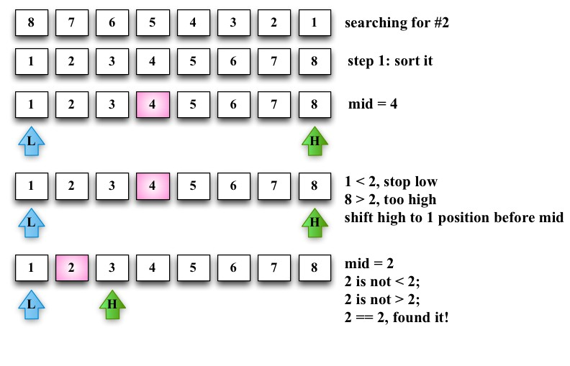
The
BinarySearchTree
class we implemented in
Chapter 8
,
Trees
, has
the
search
method, which is exactly the same as the binary search but
applied to tree data structures.

Summary
In this chapter, you learned about sorting and searching algorithms. You learned the bubble, selection, insertion, merge, quick, and heap sort algorithms, which are used to sort data structures. You also learned the sequential search and binary search (which required the data structure to be sorted already).
You can apply any logic you learned in this chapter to any data structure or any type of data. You just need to make the necessary modifications to the source code.
In the next chapter, you will learn some advanced techniques used in algorithms.

